Color Me Beautiful

Basic Beauty Skincare Collection

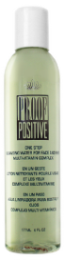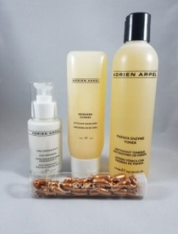

Step1. One Step (Eye Makeup Remover)..…………………………………..….$21.00

Step 2. Adrien Arpel Microderm Cleanser………………………………………..$21.00

Step 3. Adrien Arpel Papaya Toner…..……………………………..…………….$20.00

Step 4. Adrien Arpel Vitamin “C” Capsule...………………………………………$34.00

Step 5. Light Daily Defense Spf 15..………………………..……………………..$28.00

You Save $36.00 $125.00 - If purchased Separately

ONLY $89.00
Glamorous Start Collection
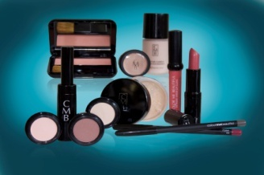

1 Camouflage Concealer $14.00 3 Color Sense Single Eye Shadows $14.00 ea.
1 Moisture Complex Liquid Foundation $27.00 1 Chroma Soft Eye Pencil $14.00
or 1 Morning Light Cream Foundation $27.00 1 Sensitive Mascara $16.00
1 Translucent Loose Powder $23.00 1 Color Sense Mineral Blush $18.00
or 1 Mineral Loose Foundation Powder $27.00 1 Lip Line Last Pencil $13.00
12 items 1 Lipstick $18.00
1 Lip Gloss $16.00
ONLY $155.00
Save $50.00
A $205.00 Value - The item #925034

Extra Skincare Treatment or Makeup Products recommended:

“C” Capsule $34 - Retinol PM Capsules $34 - Golden Glow Nourish & Firm Serum $35 UNDERGLOW $24.50 Advanced Velvet Primer $30 - Vitasome $30.00 - Eye Lift Gel $25 - Eye Perfection Crème $28.00

Papaya Brightening Polish $24 - Swiss Collagen Day Crème $26 - Moroccan Miracle Nite Crème $45

4/1 Skin Correction Complex $32 - Super Rich Moisture Cream $28.50 – Color Lock Lip Pencil $15

Color Fix Lip Sealer $15.00 - Lip Lift $17 Eye Shadow Base $16.00 - Concealer Wheel $22.50

Waterproof Brow Pencil $15 Brush on Brow Powder $17.00 - Brow Fix $15.00

