Skincare Career Pack

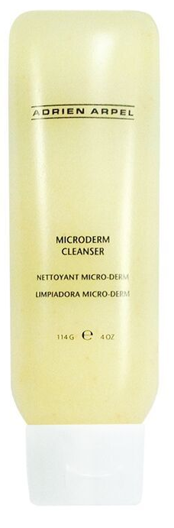
The Adrien Arpel Career Pack has everything to promote younger looking skin from start to finish. Gentle enough for all skin types, this collection of skin care products will help skin appear younger and healthier while fine lines and skin discolorations are minimized.

Micro-Derm Cleanser with Vitamin C

Benefit Statement: Gentle exfoliating gel cleanser helps dissolve and dislodge dull surface cells, removing makeup and impurities while moisturizing and nourishing the skin. Paraben, fragrance and gluten free.

Did You Know: This cleanser contains antioxidants and Vitamins A, C and E help brighten, repair and protect the skin for a fresher, smoother and more vibrant complexion. That by using this cleanser everyday your skin will look younger, smoother clearer and brighter.

How To Use: Use AM/PM. Gently massage onto damp skin using circular motions. Rinse off with warm water and pat skin dry. Avoid direct contact with the eyes.

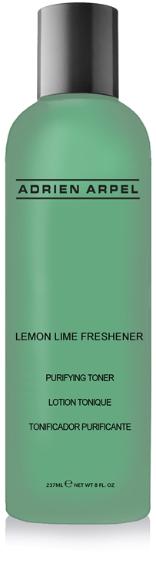

Lemon Lime Freshener

Benefit Statement: This alcohol- free blend of lemon and lime extracts is packed with Rose Hips and Vitamin C tones, purifies, brightens and refines pores. Emollients and humectants hydrate and soften the skin. Paraben, fragrance and gluten free.

Did You Know: The combination of lemon and lime extracts coupled with Vitamin C will result in clearer and brighter skin tone.

How To Use: A.M. and P.M. Saturate cotton pad. Apply with cotton pad using upward and outward motions avoiding the eye area.

Benefit Statement: An alcohol-free blend of lemon and lime extracts. Rose Hips and Vitamin C tone, purify, brighten and refine pores. Emollients and humectants hydrate and soften the skin. Paraben, fragrance and gluten free.”

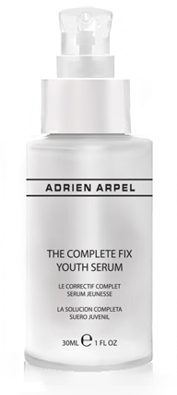

The Complete Fix Youth Serum

Benefit Statement: This remarkable complex aids in the reduction of wrinkles while providing a lifting effect for all skin types. Clinical tests with Palmitoyl Pentapeptide-4, a main ingredient, resulted in a 44% reduction of deep wrinkles, a 37% reduction of main wrinkle density and a 16% increase in lifting effect. Clinical tests with Bellis Perennis (Daisy) Flower Extract resulted in a reduction of melanin formation and anti-oxidative activity, providing significant evening of the skin tone. Fragrance, paraben, and gluten Free.

How to Use: Apply two pumps into the palms of your hands and massage hands together to warm the product. Pat over entire face and neck. Use morning and night for optimal results.

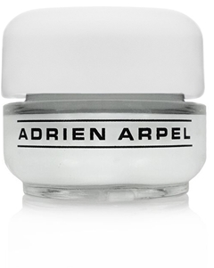
Eye Perfection Crème

Benefit Statement: This eye perfecting formula with peptides, Co-Q 10, Vitamins A, C, E, K and Mushroom extract will address all of your eye care concerns, including lifting effects, dark circles, fine lines and wrinkles. This light weight cream will absorb into the delicate skin around the eye while it hydrates, revitalizes and soothes the skin. Paraben and Fragrance free.

Did You Know: The eye area ages 5 to 10 years faster than the rest of your face. Every time you squint or smile the eye area is being damaged because your collagen fibers are breaking down. Matrixyl®, featured in Eye Perfection Crème, is a key ingredient in helping to restructure and moisturize the delicate skin around the eye so that it is better equipped to combat external aggression.

How to Use: AM/PM. Apply around the eye area and under the eyes. Gently pat cream into skin clockwise to avoid any unnecessary tugging of the skin.

C-Plex Facial Treatment Capsules
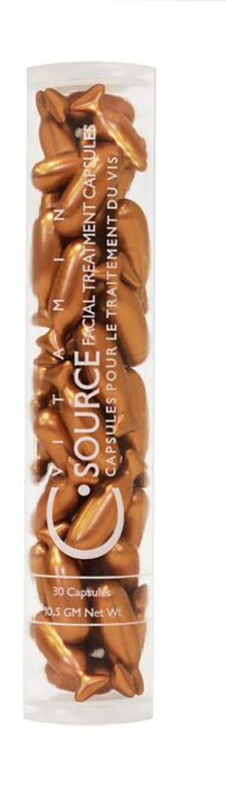
Benefit Statement: This silky formula of Vitamin C is encapsulated to ensure maximum stability and potency and it’s supercharged with an effectiveness boosting dose of Vitamin E. This power-packed antioxidant duo uses amazing properties to actively fight collagen breakdown and increase its production, this action literally delays the formation of lines and wrinkles while the vitamin C softens the appearance of existing ones. Your skin appears more softened, unlined, even-toned with a radiant glow. Thirty capsules per container, a one month supply for face and neck areas. The formula is encapsulated to ensure maximum effectiveness and stability, using a brand new V-Gel™ technology. The new soft gel capsules are derived from seaweed. Paraben, fragrance and gluten free.

Did You Know: While many anti-aging products actually thin the skin and strip off layers to achieve a more youthful effect, C Plex actually strengthens skin, reduces irritation, redness and sensitivity.

How To Use: Cut or twist the tail of the capsule and apply one capsule daily to face and neck, immediately after cleansing and toning, avoiding the eyelids. Massage onto skin and let soak in. Follow with normal treatment regimen.

C Plex can also be used to give skin an extra antioxidant boost, by adding the contents of these capsules to your specialty treatment or moisturizer by mixing them together in the palm of your hand and then applying onto face & neck using upward and outward motions.
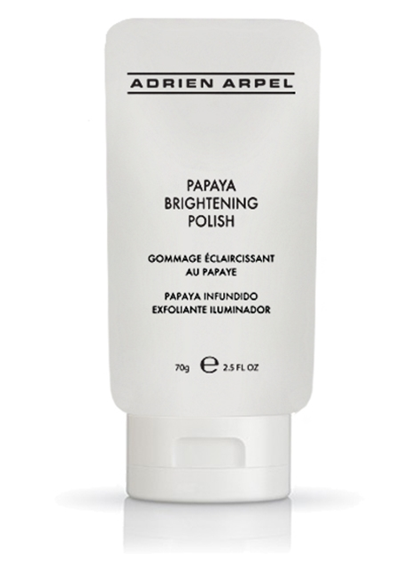

Papaya Brightening Polish

Benefit Statement: An all-in-one brightening exfoliator that refreshes your skin with papaya enzymes and AHAs while sugar exfoliates to create a refined, more even-looking complexion. This creamy polish, gently releases debris, with Sugar and Lactic Acid (AHA) promoting healthy, natural skin turnover to instantly reveal glowing skin.

How To Use: Apply to moistened skin and gently massage in circular motions. Rinse thoroughly with tepid water. For enhance results, leave on skin for 5-7 minutes.

