Color Cosmetics Career Pack
Your Career Pack includes products that are in retail packaging to show how our products are packaged for your customers. Have fun showing, demonstrating & taking orders for all of the products that are enclosed.

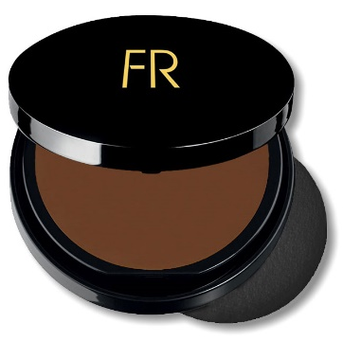
Cream to Powder Foundation

Benefit Statement: A cream foundation and powder all in one. Easy to blend and light as a feather, Flori Roberts Cream to Powder foundation will smooth uneven skin tone, cover imperfections and help skin remain velvety matte throughout the day. Fragrance free.

How to Use: Sweep sponge across product and apply using wide stokes. For sheerness, use less product for a lighter application. For maximum coverage, use more product and apply with additional stokes.
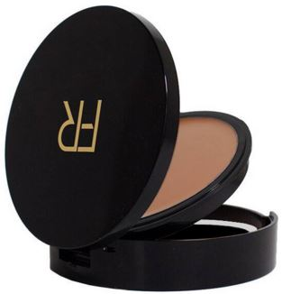

Luxury Oil Blotting Pressed Powder

Benefit Statement: This oil-absorbing, lightweight formula keeps your makeup looking fresh and matte for hours. It can be worn alone, or be the finishing touch to makeup to keep it looking fresher longer.

How to Use: Apply over makeup for a finishing touch. When using in place of a foundation, apply evenly with puff. For drier skins, use a powder brush for best results.

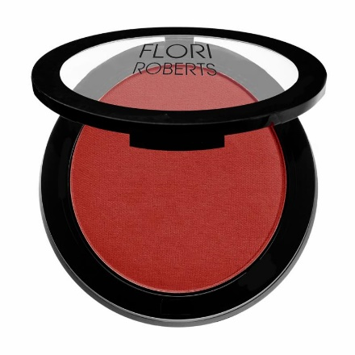
Color Pro Powder Blush

Benefit Statement: A pigment rich pressed powder blush that delivers beautiful color to flatter any skin tone. This professional quality blush is formulated to makeup artists specifications. This blush can be worn alone or over foundation, blends easily without streaking and provides you with all-day, radiant color. Fragrance free.

How to use: Apply after foundation and powder. Use Angled Blush Brush and apply to the apples of the cheek. Sweep the excess across the hairline, bridge of the nose and chin. Start with a soft application of color, building up layers depending on the intensity desired.

Waterproof Automatic Brow Pencil

Benefit Statement: Looks like a brow pencil, but this is a precision instrument for filling in and shaping up brows with an easy to use, self-sharpening point. The brush end is perfect for softening the application so brows look beautifully natural. Fragrance free.

How to use: Apply with light strokes then blend by brushing through with eyebrow brush. Repeat for build-up if desired.

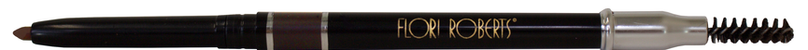

Waterproof Automatic Eye Pencil

Benefit Statement: Delivers a sexy line of water-proof color with an easy-glide, creamy formula. The smudger end makes this a must have for eye-mazing looks.

How to use: Perfect to wear alone or with eyeshadow to emphasize the beauty of your eyes.

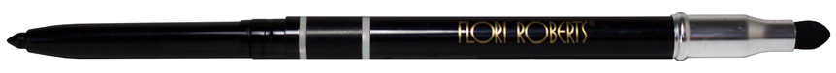

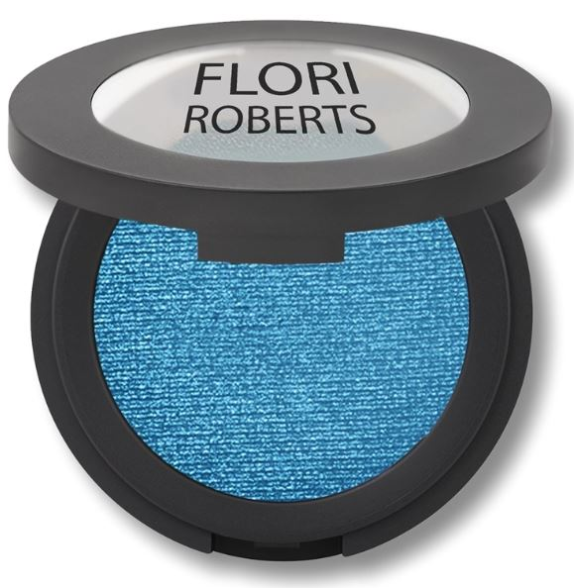
Throwin’ Shade Single Eyeshadow
Benefits: Highly pigmented color that lasts all day in an easy to use compact. Luxurious and radiant shades. Smooth application with natural light diffusing minerals. For best results, use Color Me Beautiful Eye Shadow Base first. Fragrance, paraben and gluten free.

How To Use: To encourage long lasting color for your lids, use over our eye shadow base. Apply the main accent color over the eyelid. Use the darker contour shade in the crease of the eye. A light shade should be used underneath the brow as a highlighter. Then soften and blend away any harsh lines with a make-up sponge.
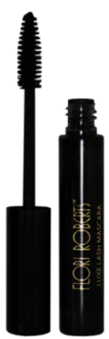
Luxe Lash Mascara

Benefit Statement: Luxe Lash Mascara provides longer, fuller lashes with increased volume and curl. Smudge and flake proof, Panthenol, Gingko and Green Tea Extracts leave the lashes flexible and conditioned. Paraben and talc free.

How to use: Apply first coat to tip of lashes; second coat to inside and outside of lashes, using long sweeping movements to fully cover lashes. Use the side of the brush to apply to lower lashes first, and then apply to upper lashes. Use the point of the brush for inner and outer lashes and for individual lash definition.

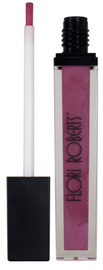
Mineral Base Lip Shine

Benefit Statement: Mineral Base Lip Shine is formulated to provide sheer, dazzling color without stickiness. Made with real, natural minerals for beautiful color and amazingly, super wear-ability. Paraben and fragrance free.

How To Use: Use alone, or over another lip shade to add shimmer or after
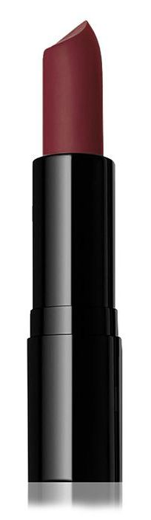
Applying lip liner.

Moisturizing Lipstick

Benefit Statement: A rich, moisturizing formula provides you with all day, creamy lip color in a range of high-impact hues. Paraben and fragrance free.

How To Use: Apply lipstick after lip base (if applicable) and lip pencil.

