GALE HAYMAN

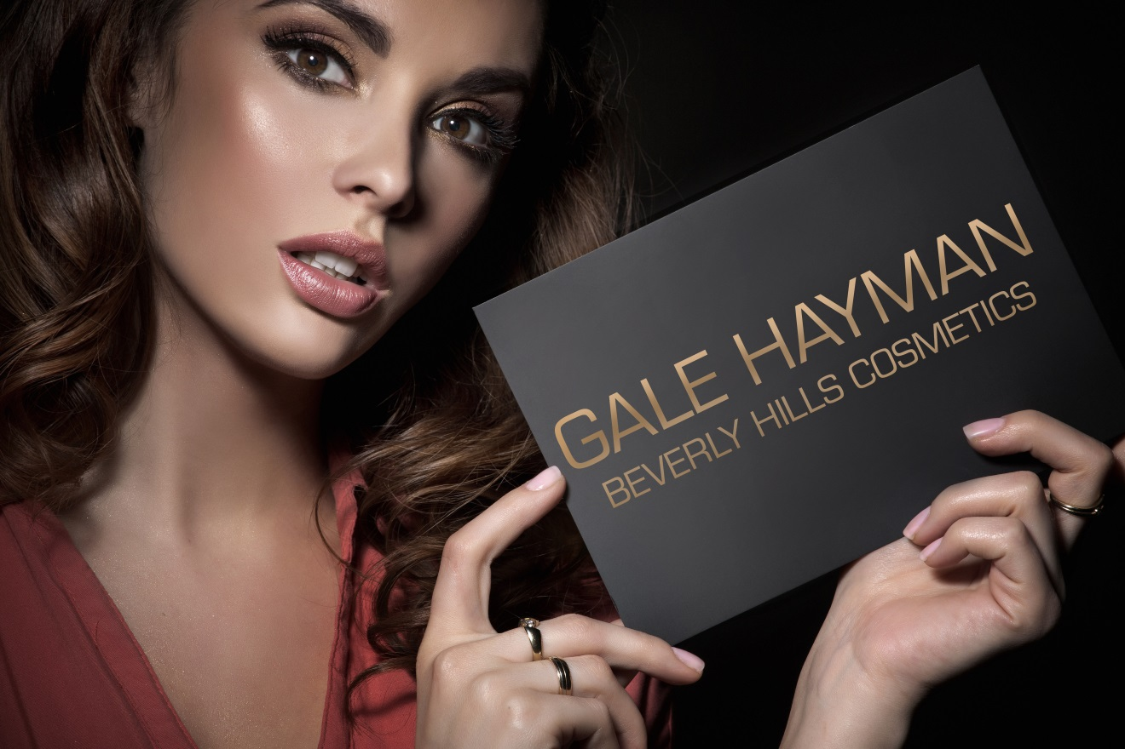

Product TRAINING MANUAL

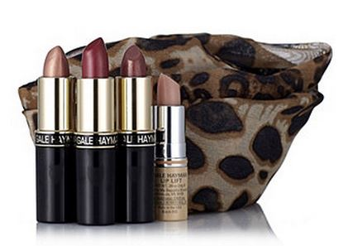
Everyone Loves a Secret. Especially a Hollywood Secret!

How do they do it? The women of Hollywood are so gorgeous. Beautiful into their 50s, 60s and 70s. From Jennifer Aniston and Angelina Jolie to Hollywood icons such as Barbra Streisand and Marilyn Monroe, the Stars know the tricks of retaining youth, beauty and sensuality.

Gale personifies Hollywood. She is synonymous with glamour, beauty and opulence. Gale is the co-creator of Giorgio, the most successful fragrance in history. And, Gale is the co-founder of Giorgio Beverly Hills, the fashion and beauty mecca for countless celebrities…and the magnet for beauty masters, and the Michelangelos of Hollywood beauty. Gale has worked closely with the Hollywood beauty virtuosos and knows their secrets. The result: Vogue Magazine recognizes Gale as “the Martha Stewart of beauty, fashion and glamour”.

Gale Hayman is frequently featured in major magazines, including Women’s Wear Daily, Elle, and Town and Country. Her book How Do I Look? A complete Guide to Inner and Outer Beauty from Cosmetics to Confidence is a must read in the circles of the bold and the beautiful.

Gale has advised some of the most beautiful women in the world. Recently interviewed by The Daily Telegraph, Barbara Streisand was asked her beauty secrets and cited Gale’s Peptide Night Cream—the only beauty product mentioned.

Gale’s marriage of sophisticated immediate anti-aging formulas with Hollywood makeup artistry is her signature, a unique blend of extraordinary, highly effective skincare as well as very specific makeup artist tricks and treats.

Gale’s instant lifting products are the cornerstone of her success, making women look younger right before their eyes. Created by a French dermatologist, Youth Lift uses a unique formula created with elastin and DNA molecules, the building blocks of rejuvenation. Within 3 minutes of application, lines and wrinkles appear smoother and lifted, resulting in a more youthful appearance.

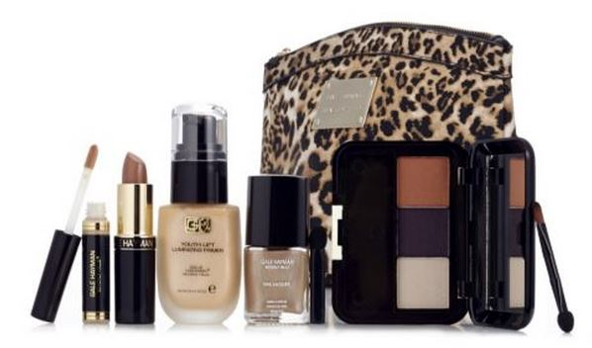
In addition, Gale’s relationships with dermatologists and top makeup artists have resulted in remarkable products and formulas to hide flaws, plump lips, refine and illuminate the skin, make eyes look larger and pores smaller. Gale’s formulations will help you create smoother and flawless looking skin.

Gale Hayman is one of the dynamic influences in Hollywood. Her expertise has earned her status as a Hollywood Beauty Hall of Famer. And, now, Gale Hayman can be your personal Beauty Advisor.

Gale Hayman products are never tested on animals.

Skin Care

ANTI-AGING

Beauty Infusion Facial Treatment Capsules – 50 Day Supply
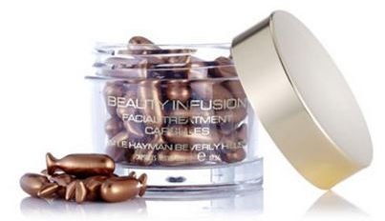
- Benefit Statement: “Beauty is ageless. Gale Hayman’s 50-piece Beauty Infusion Facial Treatment Capsules feature Vitamin C supercharged with Vitamin E, encapsulated for optimum freshness and maximum efficiency in a soft gel, topical use capsule form. This silky serum with moisturizing properties fights collagen breakdown and increase its production to ward off fine lines and wrinkles, while helping to even skin tone and give a luminous glow to the skin. Paraben, fragrance and gluten free.”

- How to Use: Twist the tail off of the capsule and apply contents under moisturizer daily, avoiding direct contact with the eyes. Apply to face, neck, décolletage and the back of hands for optimum results.

- Skin Types: All skin types, including sun damaged skin.

- Key Ingredients: Vitamins C & E, Orange Blossom Oil.

Peptide Cream
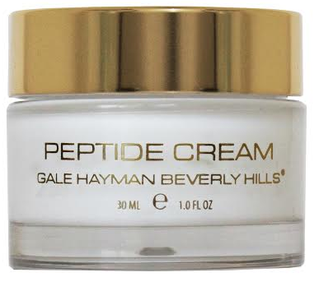
- Benefit Statement: “Reduce the appearance of fine lines and wrinkles for a more youthful appearance with the luxurious Peptide Cream from Gale Hayman. This new miracle-worker is packed with Vitamins A and E, APT-GPF, Aloe Vera Extract and 10% Argireline for reduced fine lines and wrinkles, increased skin firmness, elasticity, smoothness and skin hydration. Your most radiant skin ever is right in front of you. Paraben, fragrance and gluten free.”

- How to Use: Apply to clean skin twice daily for a more youthful appearance.

- Skin Types: All skin types.

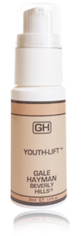
- Key Ingredients: Argireline®, APT-GPF, Tocopheryl Acetate, Retinyl Palmitate

Original Youth-Lift Face Serum

- Benefit Statement: “Youth-Lift, Hollywood’s ‘Face Lift in a Bottle’, is a unique skin primer. Developed by a French Dermatologist, it was the first product developed in the Gale Hayman brand and a #1 seller. In 3 minutes you’ll see fine lines, wrinkles and pores vanish. Will not streak or flake.”

- How to Use: Apply a light layer on clean dry skin, tapping rather than smoothing over the face for maximum effect in filling fine lines and wrinkles. Wait 3 minutes without moving your facial expression to see results. For deeper lines and wrinkles, reapply and wait again. Can be worn alone, under moisturizer, or under makeup.

- Skin Types: All skin types.

- Key Ingredients: Hydrolyzed Elastin, DNA (Natural Plant Protein).

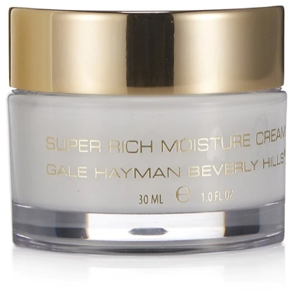
Super Rich Moisture Cream

- Benefit Statement: “The definitive solution for mature skin, providing skin protection, prevention and regeneration. Super Rich Moisture Cream contains a skin identical blend of new and unique vegetable based long chain ceramides in a blend called Skinmimics®, the result of 5 years of research. Super Rich Moisture Cream will help mature skin to be revitalized by being properly moisturized and more elastic. Skin will become more supple, hydrated and younger looking with daily use. Paraben, fragrance and gluten free.”

- How to Use: Apply to clean skin AM and PM. AM: apply a thin layer to the skin and let soak in or blot with a tissue before applying foundation. PM: apply to dry skin generously. A light application is perfect for humid weather or normal skin.

- Skin Types: Mature, dry, thin, sagging skin.

- Key Ingredients: Skinmimics®, Ceramides, Sodium Hyaluronate, Vitamin E, Tilia Cordata Flower Water (Lime Flower Water).

Eye Care

Eye Lift Gel 15 mL, 30 mL
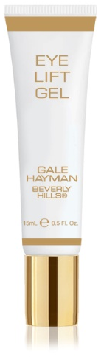
- Benefit Statement: “A concentrated, non-greasy gel that helps reduce puffiness and diminish the appearance of fine lines and dark circles. Eye Lift Gel contains a blend of plant extracts which gently hydrate, firm and soothe the delicate eye area. Fragrance free and safe for contact lens wearers.”

- How to Use: AM/PM. Apply a small amount with ring finger patting around eye area. Use alone, under or over makeup. May also be used to touch up during the day.

- Skin Types: All skin types.

- Key Ingredients: Hydroxyproline, Marshmallow Extrac), German Chamomile Extract, Euphrasia Officinalis Extract (Eye Bright), Lavender Extract, Orange Oil.

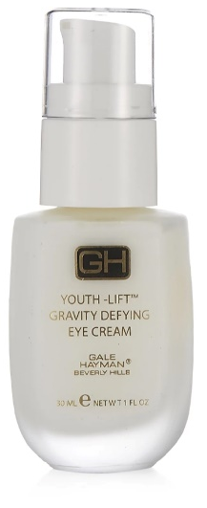
Youth Lift Gravity Defying Eye Cream

- Benefit Statement: “A light-textured, greaseless eye cream that can also be used as a masque. Formulated with a breakthrough ingredient called Dermaxyl®, created from a new generation of peptides and ceramides to aid collagen synthesis and reduce the signs of skin damage and smooth fine lines, wrinkles and crow’s feet with regular use. Paraben, fragrance and gluten free.”

- How to Use: Use nightly on clean dry skin. Apply a generous amount around eye contour area. Let the product remain on skin overnight. If irritation occurs discontinue use.

- Skin Types: All skin types.

- Key Ingredients: Dermaxyl®, Aquaxyl™, Laracare®, Sepilift DPHP™.

GOLDEN GLOW

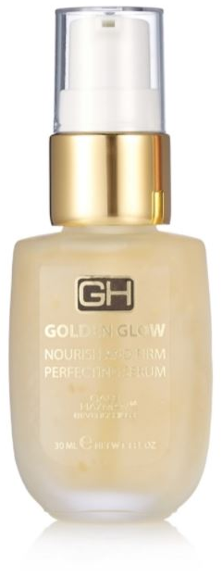
Golden Glow Nourish & Firm Perfecting Serum

- Benefit Statement: “Developed by Gale at her favorite exclusive Spa in France, this luxurious serum incorporates 24k Gold, Hylauronic Acid and an active botanical complex to help prevent and reduce wrinkles and improve skin’s moisturization and firmness. Paraben and fragrance free.”

- How to Use: Apply serum onto cleansed face morning and evening. Take a small amount and apply to skin with circular motions to allow the ingredients to penetrate the skin.

- Skin Types: All skin types.

- Key Ingredients: Glycerin, Enteromorpha Compressa Extract, Sodium Hyaluronate.

MAKE-UP MAGIC

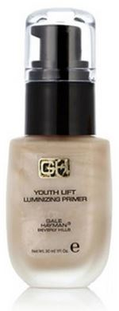
Youth Lift Luminizing Primer

- Benefit Statement: “Youth Lift Luminizing Primer helps condition and firm skin with an advanced peptide complex. The pearl finish creates a soft focus effect to minimize imperfections and create a lovely radiance. Formulated to work under or over foundation, this luminzing primer paves the way for a beautiful soft flawless finish. Paraben and fragrance free.”

- How to Use: Apply evenly to face, neck and décolletage every morning. Allow to dry for a minute and then apply foundation. May also be worn alone or over foundation highlight cheek bones and brows.

- Skin Types: All skin types.

- Key Ingredients: Syn® Glycan, Sodium PCA, Aloe Barbadensis Leaf Extract, Sodium Hyaluronate, Tocopheryl Acetate, Retinyl Palmitate.

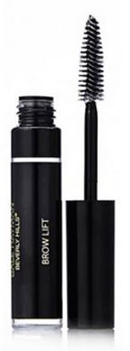
Brow Lift Gel

- Benefit Statement: “Brow Lift Gel is the perfect answer to tame unruly brows while instantly lifting the brows for a sleek and polished look. Paraben, fragrance and gluten free.”

- How to Use: Can be applied alone using the brush in an upward and outward motion to sculpt brows to perfection.

- Skin Types: All skin types.

- Key Ingredients: Propylene Glycol.

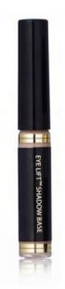
Eye Lift Eye Shadow Base

- Benefit Statement: “Eye Lift™ Eye Shadow Base is lightweight and blendable. The long-wearing formula creates a smooth canvas for crease-proof eye shadow while evening out eyelid tones. Paraben and fragrance free.”

- How to Use: Use the applicator to dab 2 – 3 dots on the eye lids. Blend with ring finger to create a smooth, even canvas. Eye Lift™ Eye Shadow Base can be worn alone for a natural yet perfect look or follow with Luxury Eye Shadow Trio.

- Skin Types: All skin types.

- Key Ingredients: Vanilla, Caprylyl Glycol.

Lip Lift 2.6 g, 3.4 g and Mint Lip Lift
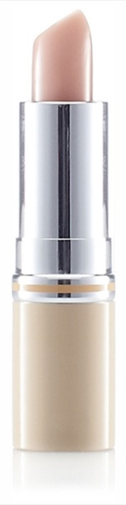
- Benefit Statement: “Lip Lift is a conditioner which instantly helps to fill in and minimize lip lines. Formulated with collagen and aloe to hydrate and soften the lips and vitamin E to fight aging free-radicals. Included in the formula is Maxi-Lip™ a natural peptide which stimulates collagen and other naturally occurring compounds, which are moisture magnets to super-saturate lip tissue leaving it moist and plump. Lip Lift also contains a sunscreen and is available in a mint flavor. Fragrance free.”

- How to Use: Wear alone or under lipstick. Gently sweep the formula over the upper and lower lips. Apply as many times as needed.

- Skin Types: All skin types.

- Key Ingredients: Aloe Barbadensis Leaf Extract, Maxi-Lip™, Collagen, Vitamin E, Benzophenone-3.

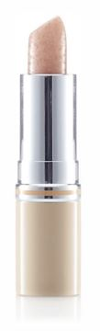
Lip Lift Buffer Balm

- Benefit Statement: “Gently exfoliate lips to remove dry, chapped skin with Gale Hayman’s Lip Lift Buffer Balm. A sweet sugar and smoothing sensation, infused with Vitamin E, Soybean, Aloe and Maxi-Lip, to exfoliate and smooth lips. Paraben and fragrance free.”

- How to Use: Apply to clean, damp lips and massage in a circular motion to exfoliate. Use a moistened cotton pad with water to gently wipe away buffer. Follow with Lip Lift.

- Skin Types: All skin types.

- Key Ingredients: Sugar, Vitamin E, Aloe Barbadensis Leaf Extract, Soybean Oil,

Lip Lift Plump & Prime
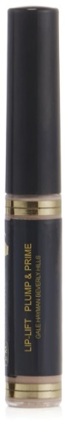
- Benefit Statement: “Lip Lift Plump & Prime does exactly what its name implies. A soft, cream makeup base specifically formulated for the lips. Slightly tinted, it neutralizes the natural color of the lips to exalt lip color and its intensity to the fullest, improving its staying power and helping to prevent feathering. Enriched with a complex of ingredients to help preserve the youth and beauty of the lips. Lip Lift Plump & Prime is paraben free.”

- How to Use: Sweep over lips as you would a lip gloss and allow a few seconds to dry before applying your favorite Gale Hayman lip color.

- Skin Types: All skin types.

- Key Ingredients: Vitamin E, Sodium Hyaluronate, Silica, Glycerin, Benzophenone-3.

color cosmetics - FACE

Soft Focus Blender Sponge
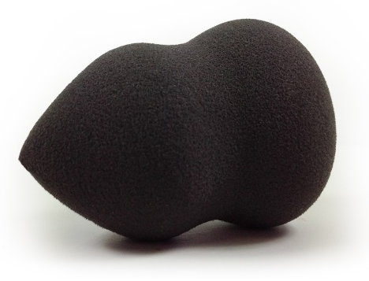
- Benefit Statement: “Creating an air brushed effect has never been easier with the new Soft Focus Blender. This revolutionary, versatile sponge application tool will give you a natural, flawless, soft focus finish every time.”

- How to Use: Wet the Soft Focus Blender with water and squeeze out any excess. Pump a couple drops of foundation onto the wide, flat end of the Blender and bounce the product across the face. Use the pointed end of the Blender around the eyes, nose, and mouth for a flawless finish. Build coverage as needed. Clean after use.

Youth Lift Soft Focus Foundation

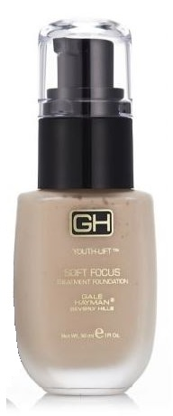
- Benefit Statement: “A technically advanced treatment foundation that, when applied, gives a flawless and natural finish. Gale Hayman’s Soft Focus Foundation gives a flexible degree of coverage ranging from light to heavy as required. It contains a light-diffusing complex that helps to minimize the appearance of wrinkles and flaws. Hydrating and anti-aging formula contains avocado, wheat germ and aloe vera. Available in three shades: Nude, Porcelain & Tan.”

- How to Use: For heavy coverage, apply with a dry cosmetic sponge. Dab on the nose, cheek, forehead and chin area, then blend with a stippling action. Pay special attention to the application around the jawline and facial features to ensure a smooth and natural finish.
- For normal to light coverage, apply with a dampened sponge, otherwise as above. Larger pore areas may require greater pressure on application. Feather blend the edges to ensure an even result.
- The pump must be primed before use and it can take up to 25 pumps to get the product flowing. Tapping the bottom of the bottle against a hard surface will also help.

- Skin Types: All skin types.

- Key Ingredients: Propylene Glycol, Aloe Barbadensis Leaf Extract, Wheat Germ Oil, Avocado Oil.

Mineral Bronzer

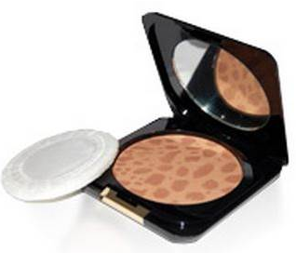
- Benefit Statement: “An earth based mineral bronzer with a golden shimmer which instantly adds a healthy glow to the face. Create the Californian sun-kissed look all year round without the damaging effects of the sun. Fragrance free.”

- How to Use: Apply over foundation, alone or in place of blush. Lightly brush over the face to create a sun-kissed tan; can be layered for deeper color. A single application of California Gold behaves very much like a translucent powder while a second or third application actually builds color.

- Skin Types: All skin types.

- Key Ingredients: Shea Butter, Titanium Dioxide, Mica, Iron Oxides, Chamomile Extract.

Hollywood Lights Luminizing Powder
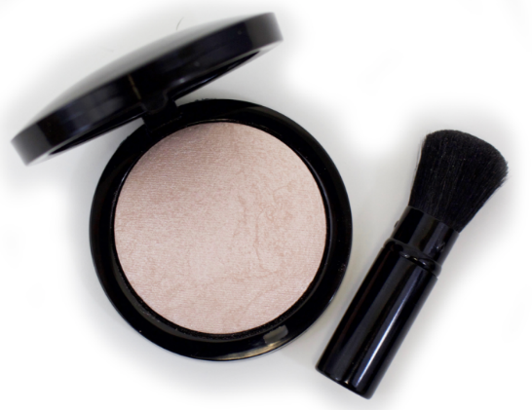
- Benefit Statement: “Put your perfect complexion in the spotlight. Create skin perfecting, age-fighting illumination for your face with Hollywood Lights Baked Luminizer from Gale Hayman. Infused with innovative micro-luminescent particles, it adds a seamless luminescence to cheeks, temples and the brow bone for a radiant, healthy-looking, gorgeous glow that transforms any light into a special effect. Hollywood Lights Baked Luminizer is a paraben, fragrance and talc free baked highlighter.”

- How to Use: Sweep across the face or apply to targeted areas, including cheekbones, brow bones, temples and the bridge of the nose.

- Skin Types: All skin types.

- Key Ingredients: Squalane, Silica, Mica, Corn Starch Extract

COLOR COSMETICS - eyes

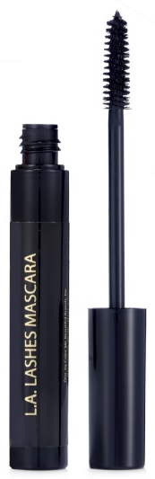
L.A. Lashes Mascara

- Benefit Statement: “L.A. Lashes Mascara from Gale Hayman helps to create the look of gorgeous, full lashes without clumping. L.A. Lashes Mascara features a unique formula that gives your lashes an instant boost and a plush brush that gives you gorgeous volume that lasts all day. Your lashes have never been this pampered! Paraben and fragrance free. Available in one shade: Black.”

- How to Use: Apply mascara from base to tip. Apply one coat of mascara, let it dry, and then apply a second coat.

- Skin Types: All skin types.

- Key Ingredients: PVP, Synthetic Beeswax

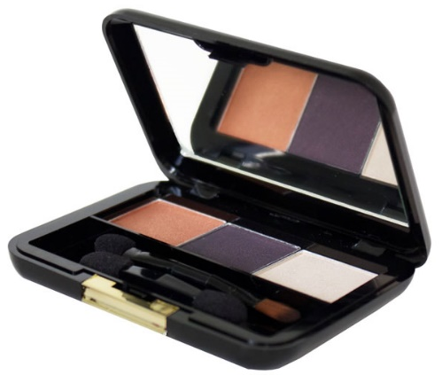
Luxury Eye Shadow Trio

- Benefit Statement: “Luxury Eye Shadow Trio combines three expertly coordinated shades in one convenient portable palette. Pearl, shimmer and matte textures merge to define eyes in a whole new light. A wardrobe of endless possibilities. Available in four combinations: Primal Instincts, Olive Grove, Champagne on Ice & Rodeo Drive.”

- How to Use: Wear each eye shadow alone or blend them for a look that’s all your own.

- Skin Types: All skin types.

- Key Ingredients: Mica, Tocopheryl Acetate (Vitamin E).

COLOR COSMETICS - LIPS

Color Lock Lip Pencil

- Benefit Statement: "Creating the perfect pucker that lasts all day is easier than ever now with Feather-Proof Lip Color. Feather-Proof Lip Color creates an invisible barrier around the lips, preventing your favorite Lipstick and Creamy Lip Color from feathering and bleeding into the lines around the lips. It's slim design, fine tip and nude color allows for mistake-proof application every time. Fragrance free."

- How to Use: To prevent feathering, trace the outline of the lips by following the contour of your mouth starting from the outer edges of the lips and working toward the center. Follow with your favorite shade of Gale Hayman Lipstick, Creamy Lip Color or Lip Glaze for color that won’t budge.

- Skin Types: All skin types.

- Key Ingredients: Triglycerides, Beeswax & Carnauba Wax.
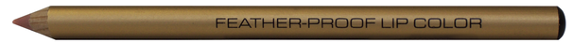

Waterproof Gel Lip Pencil

- Benefit Statement: “The new Waterproof Gel Lip Pencil from Gale Hayman glides onto the lips for a look that is feather-proof and transfer-proof. The super soft formula provides a very precise line and dries quickly for a look that is chic and sexy. Paraben, fragrance and gluten free. Available in one shade: Ballet.”

- How to Use: Outline and fill in lips, starting at the center of the mouth on both the upper and lower lip lines. Follow by applying Lipstick, Creamy Lip Color or Lip Glaze, or wear alone.

- Skin Types: All skin types.

- Key Ingredients: Pentaerythrityl Tetra-Di-T-Butyl Hydroxyhydrocinnamate, Carnauba Wax, Nylon-12.
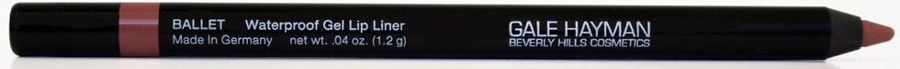

Lip Lift Tint
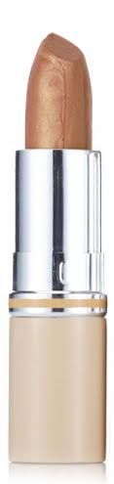
- Benefit Statement: “Three brand new, drop-dead gorgeous Lip Lift Tints featuring Maxi-LipTM, a natural peptide that gives lips a super-charge of moisture that will leave them feeling soft and plump, and a hint of mint for sweetness and smell. Perfect for layering, each shade glides on the lips smoothly for a natural flush that delivers a gorgeous pop of color and hydration. Fragrance free. Available in three shades: 14K Gold, Blush & Blackberry.”

- How to Use: Apply as you would a lipstick. Lip Lift Tints can be word alone or over Lip Lift, Feather-Proof Lip Color, Creamy Lip Color or Lipstick.

- Skin Types: All skin types.

- Key Ingredients: Propylene Glycol, Tocopheryl Acetate (Vitamin E), Soybean Oil, Benzophenone-2, Aloe Barbadensis Leaf Extract.

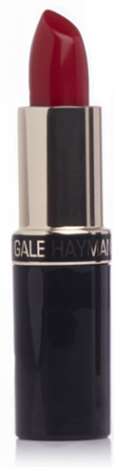

Lipstick

- Benefit Statement: “This rich cream lipstick contains a high level of pigment to deliver a more intense and vibrant color for sexy, glamorous lips. Paraben and fragrance free. Available in 21 shades.”

- How to Use: Apply over Lip Lift or alone.

- Skin Types: All skin types.

- Key Ingredients: Squalane, Tocopheryl Acetate (Vitamin E), Aloe Barbadensis Leaf Extract, Vanillin, Soybean Oil.

Mineral Lip Shine
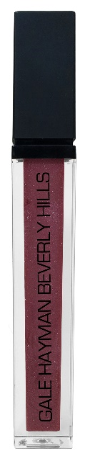
- Benefit Statement: “These new Lip Shines from Gale Hayman are formulated to provide sheer, dazzling color without stickiness. Made with real, natural minerals for beautiful color and amazing super wear-ability. You can wear it alone or over another lip shade to add the perfect amount of shimmer and shine while leaving your lips soft and supple every time. Paraben free. Available in five shades: Posh Pink, Sherry Ice, Fuchsia, 14K Gold & Melrose.”

- How To Use: Wear alone, or over Lip Lift or another lip shade to add shimmer

- Skin Types: All skin types.

- Key Ingredients: Vitamin E, Beeswax.

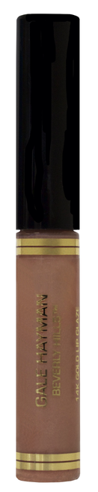
Lip Glaze

- Benefit Statement: “14K Gold Lip Glaze is the latest and greatest product of Gale's best-selling, iconic shade. This long-lasting, saturated glaze glides on for full coverage in one smooth stroke. The quintessential 14K Gold shade is perfect for layering with your favorite lipstick, adding the perfect amount of shimmer and shine while leaving your lips soft and supple every time. Paraben and fragrance free."

- How to Use: Wear 14K Gold Lip Glaze alone, over Lip Lift or over your favorite shade of Lipstick for a glossy look.

- Skin Types: All skin types.

- Key Ingredients: Tocopheryl Acetate (Vitamin E), Shea Butter, Mineral Oil, Mica.

Creamy Lip Color
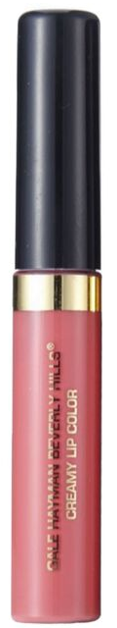
- Benefit Statement: “This highly pigmented, long lasting saturated color glides on for full coverage in one smooth stroke. Advanced copolymers provide enhanced wear properties and optimal adhesion. Paraben and lanolin free. Available in three shades: Flamingo, Cali Coral & Soft Pink.”

- How To Use: Apply over Lip Lift or alone. Ease of one stroke application with the doe foot applicator across upper and lower lips.

- Skin Types: All skin types.

- Key Ingredients: VOLULIPTM, Lipex, Silica, VP/Hexadecene Copolymer.

COLOR COSMETICS - Nails

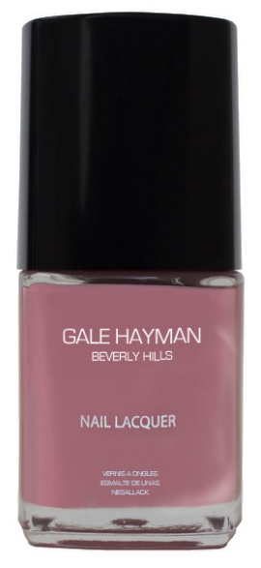
Nail Lacquer

- Benefit Statement: “State-of-the-art formula strengthens and moisturizes the nails while delivering ultra-long-wearing, high-shine, chip-resistant color. Designed to apply evenly without streaking. Formaldehyde, toluene, DBP, paraben and fragrance free. Available in seven shades.”

- How to Use: For a flawless nail lacquer application first apply basecoat on a clean, dry nail. Allow to dry to the touch prior to applying nail lacquer. Apply two coats of nail lacquer. Allow each coat to dry prior to applying additional coat. Finish with topcoat if desired.

