USING YOUR NEW SEASONAL COLOR DRAPES

Color Draping is a simple and fun way of using colored fabric to help assess the color palette of a customer. This gives you credibility and a visual basis for suggesting a collection of makeup colors will be flattering on a customer. It is also a lot of fun!

The enclosed Warm Rust and Green Apple drapes, as well as the Cool Light Blue and Scarlet drapes, have been carefully selected so both you and your clients can clearly see their Seasons. A little background color analysis: there are two key factors in assessing a person’s Season: (1) the lightness or deepness of hair color, and (2) the warmth or coolness of hair color.

CONTENTS

You’ll find four drapes in the following shades:

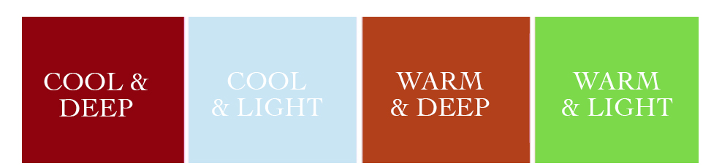
Scarlet Light Blue Rust Green Apple

DEFINING WARM AND COOL

Warm – A shade which is closest to gold on the color wheel.

Cool – A shade which is closest to blue on the color wheel.

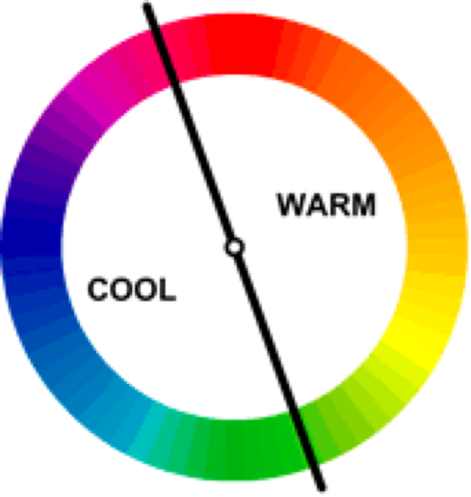
Color Wheel

Warm and Cool are comparative concepts. A single shade of blue may be warmer or cooler than another shade of blue. A shade of red can be warmer or cooler than another shade of red.

Understanding this concept helps us understand the basic Color Me Beautiful principle that anyone can wear any “color”. The key to wearing makeup and clothing colors which work best for you are in the shade nuances within that color.

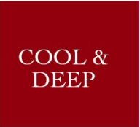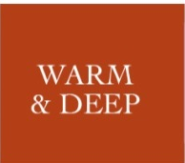

By knowing if an individual is Cool or Warm, you’re providing enormous value – in fact, most of the value – to your clients’ understanding of their best makeup colors.

DEFINING LIGHT AND DEEP

Light – The amount of white in a color.

Deep – The amount of darkness in a color.



Light Deep

DETERMINING SEASONS

Spring - A palette that represents individuals whose hair is generally Warm and Light. The spring color palette tends to be bright shades or the warmer hues of colors. TIP: A visual memory trick is to envision the blossom colors of spring, warm pink zinnias, blue bells, daisies and crocus. SPRING – blossoms.

Summer - A palette that represents individuals whose hair is generally Cool and Light. The summer color palette tends to contain muted shades. TIP: A visual memory trick is to envision the hazy light of summer, muting all the colors. SUMMER – haze.

Autumn - A palette that represents individuals whose hair is generally Warm and Deep. The autumn color palette tends to be rich, in shades that one would see in the fall. TIP: A visual memory trick is to envision the colors of changing leaves in the fall. AUTUMN – leaves.

Winter - A palette that represents individuals whose hair is generally Cool and Deep. The winter color palette tends to be bold in jewel tones. TIP: A visual memory trick is to envision lights of the Holiday season in fuchsia, sapphire blue, emerald green and bright purple. WINTER – lights.

DOING A COLOR ANALYSIS

You will need a mirror so your clients will be able to see how they look as you drape. You’ll find Color Analysis Mirrors for draping on the Sales Aid Order Form (item# 55134). It is best to ask clients to remove their makeup. With no makeup and neutral overlay to hide the colors of her clothes, you and your client will find it easier to see the results of the draping. However, removing makeup is not a requirement. Draping can be done successfully for clients with makeup on.

The best lighting is natural lighting as it’s harder to see the nuances of color in dim lighting or under fluorescent lighting. However, if natural lighting isn’t available, incandescent lighting works. In a pinch, simply removing a lampshade will flood a room with incandescent light.

Finally, color draping is best done as a group of at least three people. Often, it can be hard for an individual to see past a lifetime of color habits. Having an audience to observe the transformation will add enthusiasm and support.

You will be using your four fabric shades to “test” your client’s Season. Scarlet, which flatters a Deep and Cool (Winter) person. Light Blue, which flatters a Light and Cool (Summer) person. Rust, which flatters a Deep and Warm (Autumn) person. Green Apple, which flatters a Warm and Light (Spring) person.

Scarlet Light Blue Rust Green Apple

To drape a client, put the drapes together and place under your customer’s chin so they lay across her chest up to her neck. Be sure to cover the clothing immediately below her face.

HAIR COLOR IS KEY

At Color Me Beautiful, the first indicator for color palette is hair. Hair is the single most prevalent part of an individual’s “colorscape”. The first hair clue is Lightness or Depth (tone or shade) of hair color. Looking at a woman’s hair color, would her hair be described as light or dark? If her hair color falls in the middle (medium brown, medium red) between light and dark, simply make your best guess. You will back up these observations using your color drapes.

Next we will study the hair color for strong gold or red highlights. Without strong gold or red highlights (example black hair with bluish high lights, ash brown, platinum or ash blonde) a person has cool toned hair. If there are strong gold or red highlights (example honey blonde, golden brown, golden red) then you are looking at warm toned hair.

See the figure below. This is a quick reference chart for hair color. With a little experience this chart will not be needed. A note: there are a few exceptions to this system. One of which is salt and pepper gray hair, which is typically considered Cool and Deep (Winter), and the popular Burgundy hair color, which is also considered Cool and Deep (Winter).
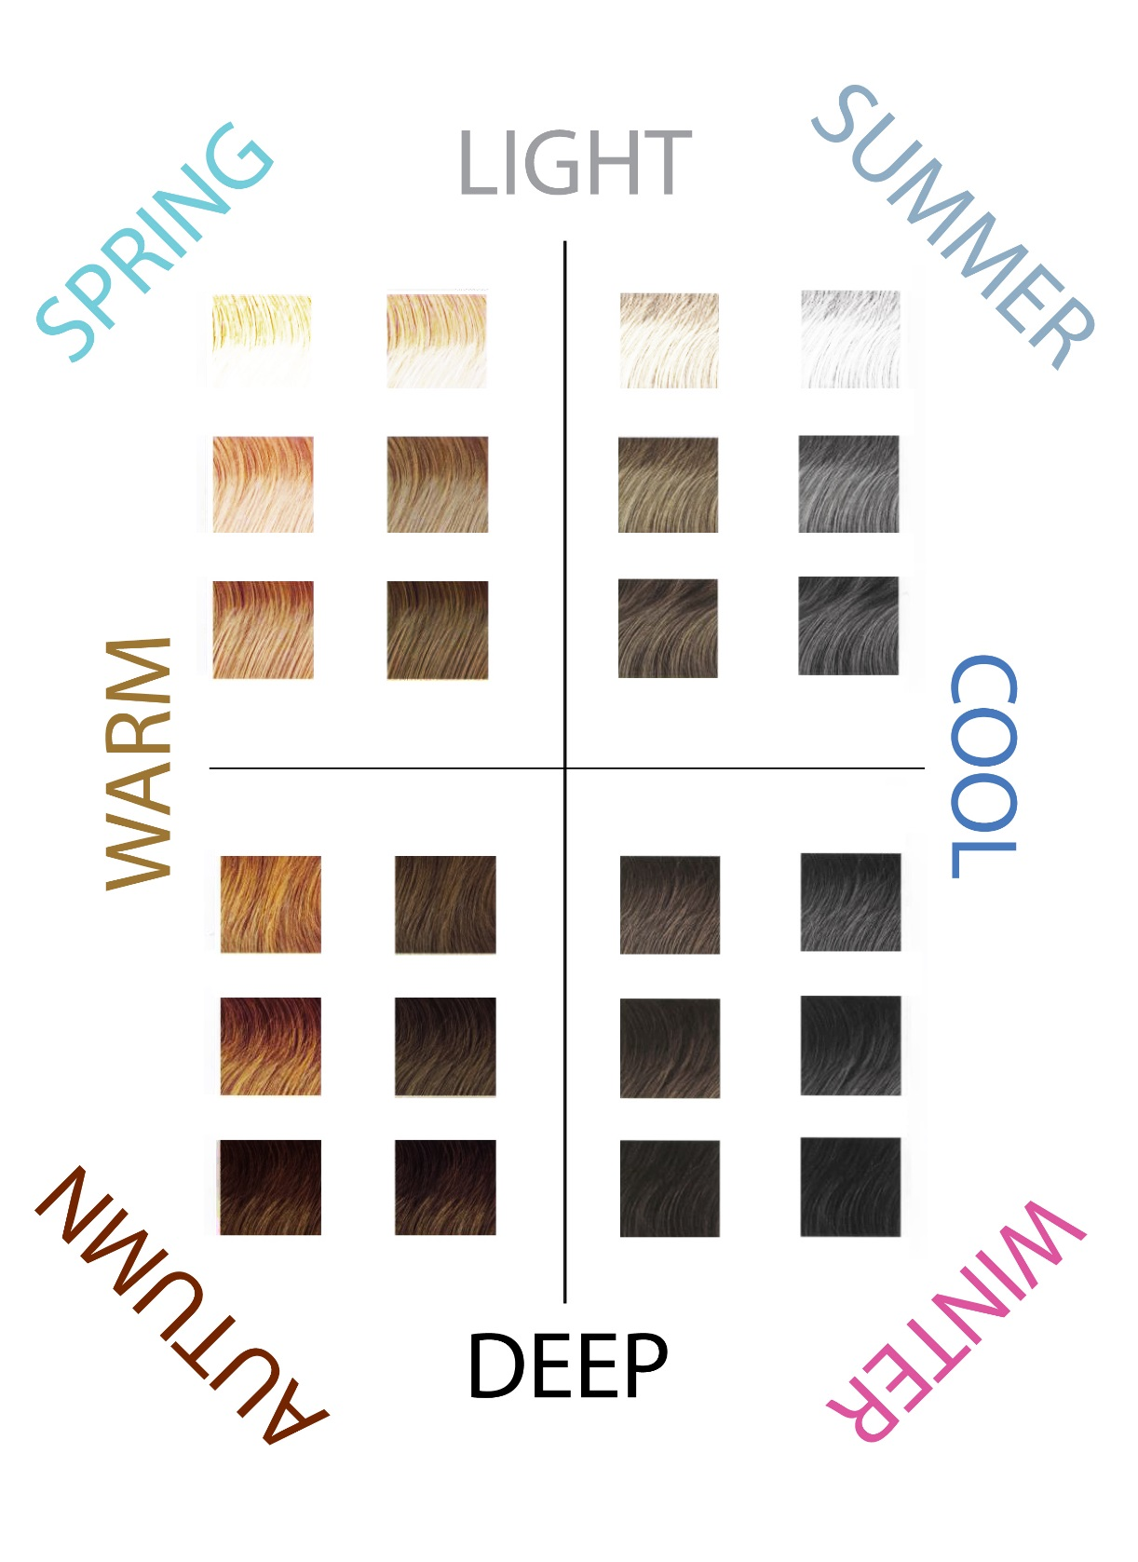

THE DRAPING PROCESS

If you see she is Warm and Deep (Autumn), place all four drapes on her chest, under her chin with the two Warm (Autumn and Spring) drapes on the bottom of the stack (see below). If you believe she is Cool, place them with the two cool (Summer and Winter) drapes on the bottom. Allow the client to “see herself” in the wrong shades first. Peel back the drapes one at a time.

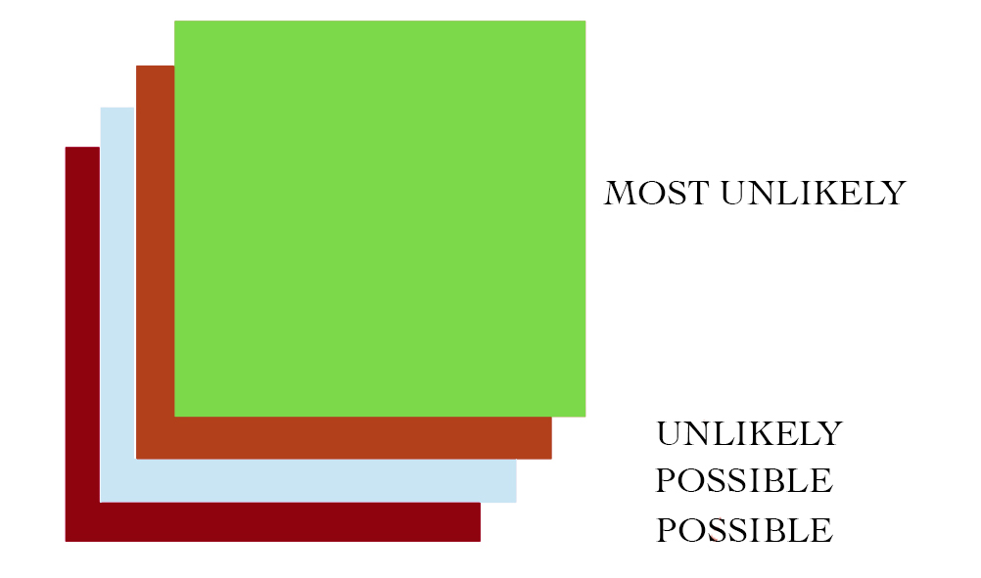

Once you are down to the two RIGHT drapes, toggle back and forth. Do this several times so she can see how her face glows with the right color and how shadows and lines become more prominent with the wrong color, making her look older and tired. The shade of drape and visual clues will give you a Season. See the chart for summary.
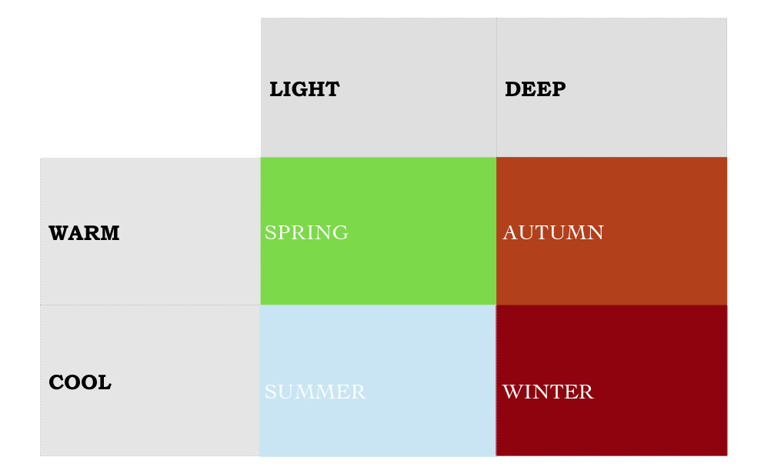
BEST SHADE DRAPE – GREEN APPLE

If your clients best drape is GREEN APPLE, she is likely a SPRING. Seasonally, if a person is both light and warm, she is a Spring, picture Nicole Kidman, Cameron Diaz, Kate Hudson or Brad Pitt.

Springs look best in Warm cosmetics colors, warm pink, salmon for lips and warm pink, golden brown, warm green with a warm highlighter like the palest peach, for the eyes for eyes. The best mascara for a Spring is brown. TIP: Frosted shades for Springs will include rose or gold frost.

BEST SHADE DRAPE – LIGHT BLUE

If your clients best shade is LIGHT BLUE, she is likely a SUMMER, envision Diane Sawyer, Hillary Clinton Linda Evans or Jude Law. While considering these celebrities, picture the difference in their appearance. Note that there is a golden quality to the Springs, while the Summers appear more Icy.

Summer’s more icy colors should be reflected in their makeup with lip colors including cool pink, rose frost and mauve. The eyes require shades like rose browns, sterling gray, mauve, with a cool highlighter such as pale pink. Black mascara is the best choice for a cool season like Summer. TIP: Frosted shades for Summers will include silver frost.

BEST SHADE DRAPE – RUST

Next we consider people who look best in the RUST drape. Deep and warm, these persons are AUTUMNS. Debra Messing is a great example, as is Eva Longoria, Julia Roberts, Beyoncé and Colin Firth.

In cosmetics Autumns look best in the shades of an autumn landscape, whether it is bronze, terra cotta or brick for the lips or chocolate brown, olive, with warm tone highlighter like an off white for the eyes. Autumn women of color can take advantage of their deeper skin tones by choosing bolder shades for the eyes and lips, as long as they are warm. TIP: Frosted shades for Autumns will include gold frost.

BEST SHADE DRAPE – SCARLET

If your client looks best in the SCARLET drape, she is likely a WINTER, with deep and cool hair color. Imagine Courtney Cox, Megan Fox, Zach Efron, Kim Kardashian and George Clooney.

Winters wear the boldest cosmetic shades of any of the seasons. Winter lip palettes include plum, berry, bold pink and even red. Charcoal, plum, deep chocolate brown flatter Caucasian Winters. Winter women of color can experiment with jewel toned eye colors like sapphire and amethyst. A cool highlight shade, such as pale pink or even a sheer white frost are all good eye color choices for Winters. The best mascara shade for a winter is black. TIP: Frosted shades for Winters will include pearl or silver frost.

IMPORTANT TIP: Clothing is also a good indicator of what colors your customer feels most comfortable in. If her hair and clothing tend to be Warm, bingo! You’ve got a good feel for what she likes to wear.
MAKE MAGIC: COMMUNICATE WHAT YOU SEE

It’s important you talk your client through what she’s seeing, noting “The wrong colors will make your complexion look pale, sallow and accentuate lines under the mouth and dark circles under the eyes. The wrong color will compete with your face while the right color will light up your face, smoothing and clarifying the complexion, reducing lines, shadows and circles. The face will come alive and your eyes will appear luminous”. Also explain that wearing the right colors will limit shopping mistakes, cosmetics in their drawers which they don’t use and clothing they never wear.

If you’re not sure after draping her, and looking at her hair and clothing color preferences, then look at the color of her jewelry. Tell her she looks good in both Warm and Cool and move her into the palette which works with her jewelry as jewelry generally represents a customer’s biggest investment.

Obviously, it’s important not to argue with a customer. If she has a strong opinion on what her color preferences are, generally its best to go with that and have the drapes confirm what she’s already doing. Remember that one of the big benefits to your customer is that, by staying in either the Warm or Cool palette, all of the makeup, jewelry and clothing selections she makes will automatically coordinate. She’ll look so much more pulled together if her makeup is all Cool, her clothing is all Cool and her jewelry is Cool, then if she wears some Cool items and some Warm items.

Your big payoff is in getting her into the right collection of cosmetic colors. Collection is the keyword. Through the concept of a coordinated look and by draping, you should be able to sell your customer a lipstick, eye shadow, blush, eyeliner, lip pencil, etc. You can use the enclosed Warm/Cool Makeup Wardrobe Chart with our suggested cosmetic color collections.

Never forget to emphasize good skincare. The beautiful new palette will look even better with properly cared-for skin. Help her to achieve the perfect canvas for makeup by prescribing a skincare regime for her.

MOST IMPORTANT TIP: This process information is powerful enough to change lives. This color kit and information represents an introductory level of Color Analysis. Experience, practice and continuing education makes the perfect Color Consultant.

