Skincare Training Sheet

The Flori Roberts Skincare products included in your kit has everything to promote healthy skin
from start to finish. There are products for every skin type so your skin will look younger and feel
fantastic.

Ultimate C Cleanser
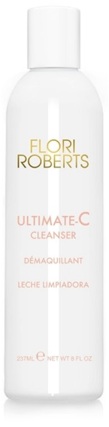
Benefit Statement: This luxurious, creamy formula helps to maintain skin’s moisture balance while removing makeup and impurities. Formulated with Vitamin C and a blend of botanical extracts, this gentle formula leaves the skin feeling soft, soothed, pampered, and looking brighter and more radiant. Paraben, fragrance and gluten free.

Did You Know: Cleansing the face with a Vitamin C cleanser can brighten and even skin tone while also aiding in reversing skin roughness.

Skin Types: All skin types

How to Use: Massage over wet face and neck, rinse with warm water. Follow with Ultimate C Clarifying Toner for luminous clarity.

Ultimate-C Capsules
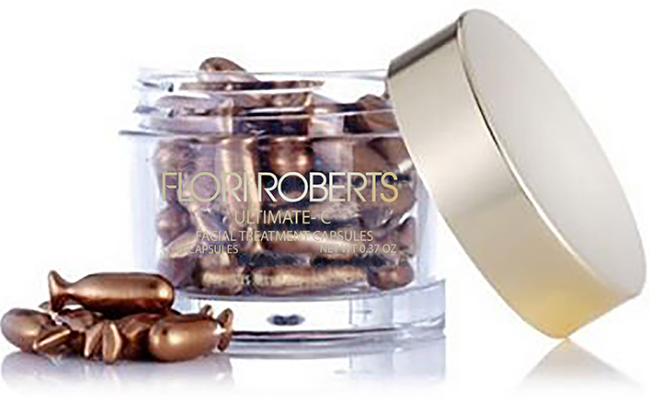
Benefit Statement: This silky formula of Vitamin C is encapsulated to ensure maximum stability and potency and is supercharged with an effectiveness boosting dose of Vitamin E. This power-packed antioxidant duo actively fights collagen breakdown while increasing its production. This delays the formation of lines and wrinkles while the vitamin C softens the appearance of existing ones. Your skin appears softened, unlined, even toned, with a radiant glow. The formula is encapsulated to ensure maximum effectiveness and stability, using
V-Gel™ technology. The new soft gel capsules are derived from seaweed. Paraben, fragrance and gluten free.

Did You Know: While many anti-aging products actually thin the skin and strip off layers to achieve a more youthful effect, Ultimate-C Capsules actually strengthens skin, reduces irritation, redness and sensitivity.

How To Use: Cut or twist the tail of the capsule and apply one capsule daily to face and neck, immediately after cleansing and toning, avoiding the eyelids. Massage onto skin and let soak in. Follow with normal treatment regimen.

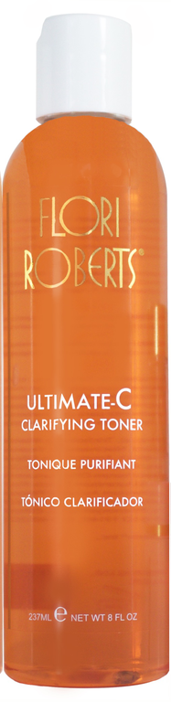
Ultimate-C Clarifying Toner

Benefit Statement: An alcohol-free toner enriched with Vitamin C and a blend of Lemon and Grapefruit extracts that protects the skin against signs of aging. Ultimate C Clarifying Toner softens and smoothes the skin while brightening for a luminous clarity. Paraben and gluten free.

Did You Know: A toner is an important step between cleansing and moisturizing. Toners provide extra cleansing power, balance ph, refresh the skin and minimize the pores. Citric Acid invigorates the skin, removing deal cell that build up throughout the day and night, It also cleanses and purifies the skin naturally, without leaving the skin feeling dry.

Skin Types: All skin types.

How to Use: After cleansing, saturate cotton pad with Ultimate-C and smooth over face and neck. Use AM and PM.

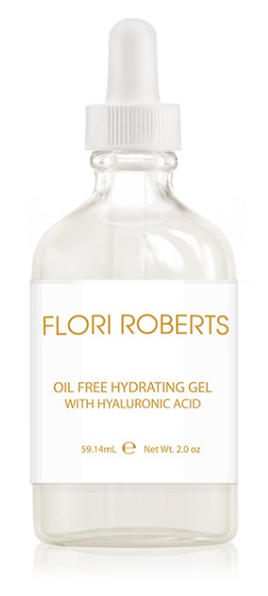
Oil-Free Hydrating Gel With Hyaluronic Acid

Benefit Statement The Oil-Free Hydrating Gel with Hyaluronic Acid is an innovative moisturizer that rehydrates and strengthens the skin without the use of oil-based ingredients. Hyaluronic Acid combined with Seaweed Extract work together in a smooth and refreshing gel. The Seaweed Extract ingredient also helps strengthen the epidermal barrier of the skin, providing enhanced protection and water locking benefits.

Did You Know: Seaweed Extract combined with Hyaluronic Acid together provide the skin with superior levels of hydration.

Skin Types: Normal, Oily, Combination

How to Use: Apply onto clean face and neck until absorbed. Use alone or over your specialty treatment.

Exfoliating Facial Scrub & Primer

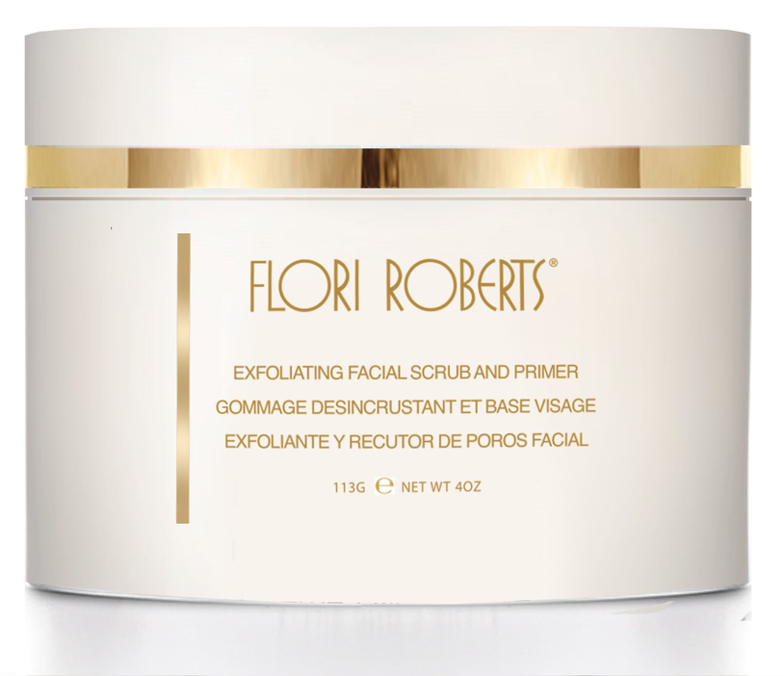
Benefit Statement: Nature’s best blended together in this natural facial exfoliant and primer. Almond, Walnut and Papaya extracts gently exfoliate and melt away dead skin cells. Honey, Wheat Protein and Sweet Almond Oil condition, soften and moisturize the skin. Paraben free. No artificial coloring.

Did You Know: The best time to exfoliate is after cleansing and before toning. This will open the skin up and prime it for your next step. Exfoliating Facial Scrub & Primer contains crushed almonds and walnut shell powder to gently buff away dead skin cells. And, Papain, a papaya enzyme, which is a gentle exfoliating agent that helps to restore the even-tone look of sin by accelerating the process of removing dead skin cells.

Skin Types: All skin types

How to Use: Gently massage over face. Rinse thoroughly.

