

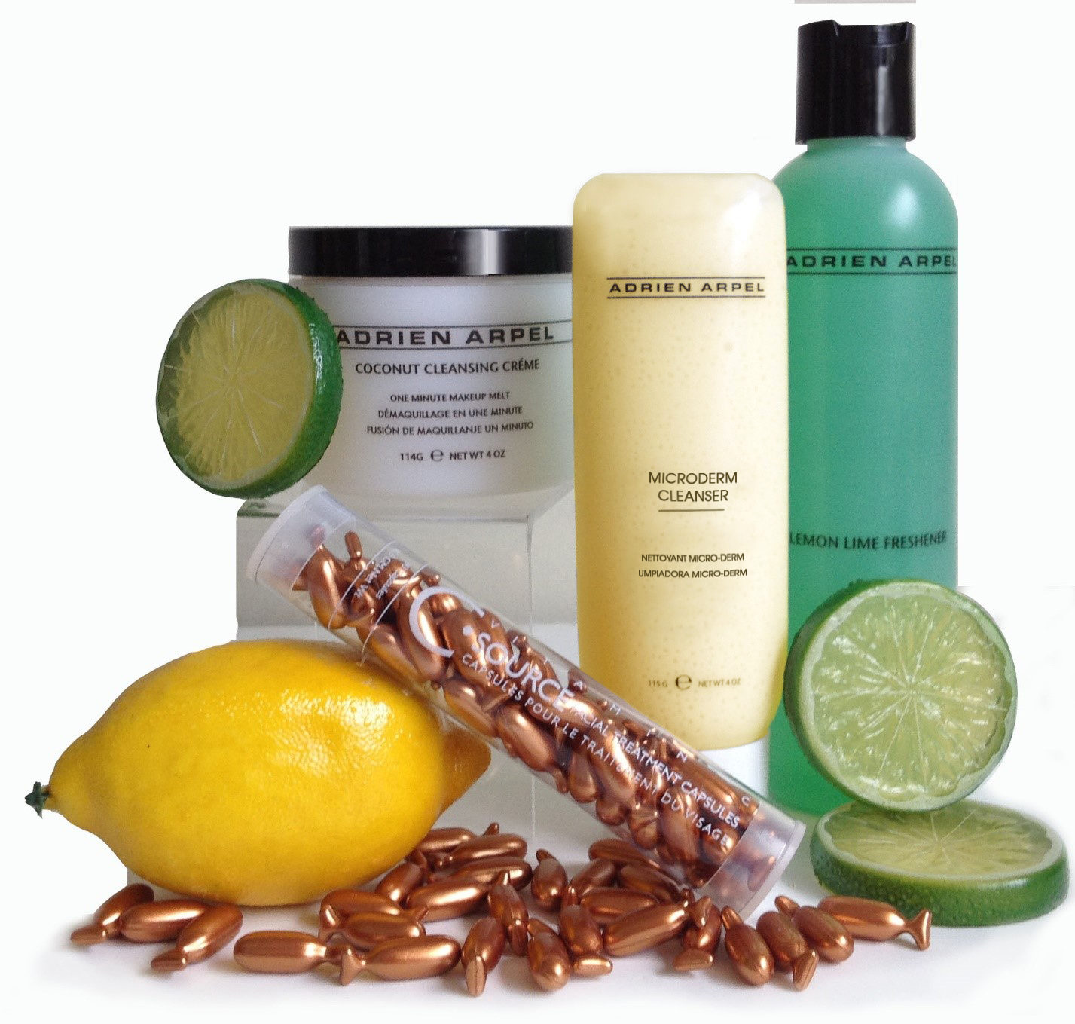

Product TRAINING MANUAL

Adrien Arpel’s popularity began within the in-store salons of department stores. The brand built upon this spa pedigree and has evolved into a naturally based, scientifically advanced skincare and anti-aging product line.
Adrien Arpel features fruits, vegetables and botanical extracts characterized in such products as Honey & Almond Scrub, Papaya and Coconut Cleansers and Lemon Lime Freshener, to name a few. In addition to the outstanding healing benefits of using these naturally derived ingredients, the products are a delight of delicious scents and palpable textures.
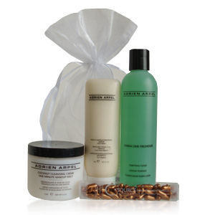
Adrien Arpel products are tried and true. Proven to be effective and known to promote beautiful, healthy, more youthful skin. The 4 in 1 Skin Correction Complex, the C Source Capsules and the Bio-Cellular Night Cream are some of the most popular anti-aging products available anywhere. Within 30 days, a customer will see the benefits of younger looking and glowing skin. The cleansers, toners, scrubs, masks, serums and SPF moisturizers provide the essentials for a daily regime which keep the skin supple and soft.
Adrien Arpel delivers a superior beauty experience. The products do not contain questionable ingredients such as parabens nor fragrance. Arpel is known internationally, affordably priced, and has a successful track record in department stores throughout the US as well as on the popular HSN shopping channel.

Adrien Arpel products are never tested on animals.

Skin Care

Cleansers

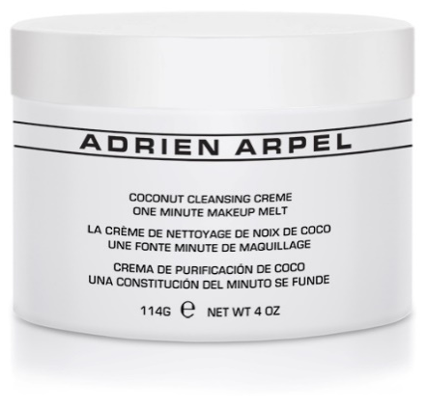
Coconut Cleansing Crème

- Benefit Statement: “This one minute makeup melt gently dissolves makeup and daily grime while safflower, coconut and wild honey hydrate and soften the skin. Paraben and gluten free.”

- How to Use: Every evening, apply freely over face and neck. Leave on one minute while melting action takes place. Remove with tissue or moist washcloth.

- Skin Types: Dry, mature skin.

- Key Ingredients: Coconut Oil, Rose Hips, Beeswax, Passion Flower Extract, Orange Flower Extract, Nettle Extract.

Micro-Derm Cleanser

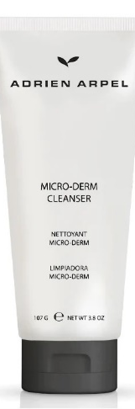
- Benefit Statement: “Gentle exfoliating gel cleanser helps dissolve and dislodge dull surface cells, removing makeup and impurities while moisturizing and nourishing the skin. Antioxidants and Vitamins A, C and E help brighten, repair and protect the skin for a fresher, smoother and more vibrant complexion. Paraben, fragrance and gluten free.”

- How to Use: AM/PM. Wet skin and gently massage using circular motions. Rinse with warm water. Avoid direct contact with the eyes.

- Skin Types: All skin types.

- Key Ingredients: Phospholipids, Vitamins E & A, Green Tea Extract, Ginkgo Biloba Extract, Orange Peel Oil, Tangerine Peel Oil.

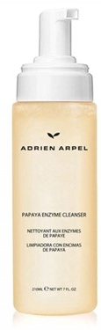
Papaya Enzyme Cleanser

Benefit Statement: A high-tech self foaming cleanser that removes makeup and debris, and smooths the skin, while natural papaya fragrance livens the senses.Enriched with exfoliating papaya (papain) enzymes, this remarkable cleanser completely removes impurities deep within the pores. Leaves skin immaculate, radiant, and totally energized.

- How to Use: AM/PM. Pump 3 puffs into palm. Massage over skin and rinse with warm water.

- Skin Types: All skin types.

- Key Ingredients: Papain, Emblica, Papaya Fruit Extract, Cucumber Extract, Aloe Barbadensis Leaf Extract.

toners

Papaya Enzyme Toner
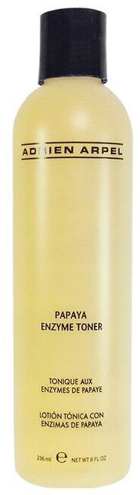
Benefit Statement: Your go-to toner for a healthy, radiant complexion. With the aroma of fresh papayas, this toner is made with a blend of natural ingredients, including ivy extract, cucumber extract, arnica montana flower extract, and silk amino acids. Ivy extract tones and tightens skin, while cucumber extract helps regulate moisture and soothe irritation. Arnica Montana flower extract offers anti-inflammatory benefits, and silk amino acids keep skin hydrated and refreshed. Papaya Enzyme Toner smells excellent, has a pleasant aroma, and will leave your skin soft and smooth.
- How to Use: Use morning and night after cleansing. Apply with cotton pad and wipe entire face and neck.

- Skin Types: All skin types.

Key Ingredients: Emblica, Ivy Extract, Cucumber Extract, Arnica Montana Extract, Papain, Cucumber Extract, Silk Amino Acids

Lemon Lime Freshener
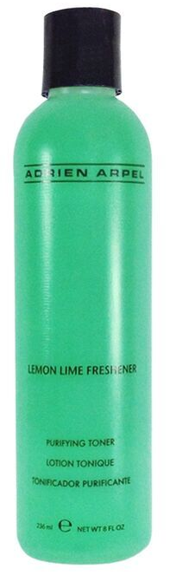
- Benefit Statement: “An alcohol free blend of lemon and lime extracts. Rose Hips and Vitamin C tone, purify, brighten and refine pores. Emollients and humectants hydrate and soften the skin. Paraben, fragrance and gluten free.”

- How to Use: Use daily after cleansing face to remove all traces of cleanser. Apply with a cotton pad using upward and outward motions avoiding eye area.

- Skin Types: Combination/oily skin.

- Key Ingredients: Aloe Barbadensis Leaf Juice, Vitamin C, Rose Hips, Lemon Peel Oil, Lime Peel Oil.

Moisturize
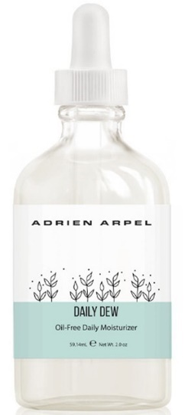

Daily Dew Oil Free Gel Moisturizer

- Benefit Statement: “A lightweight moisturizer, formulated with seaweed extract, hyaluronic acid, and citric acid to boost radiance and hydration.”
- How to Use: Apply to face and neck as needed to hydrate.
- Skin Types: All Skin Types
- Key Ingredients: Seaweed Extract, Sodium Hyaluronate, Propylene Glycol, Ethylhexylglycerin, Citric Acid

EXFOLIATE AND RENEW

Honey and Almond Scrub
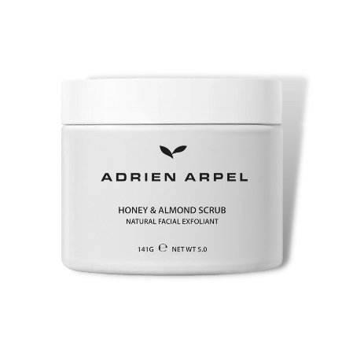
- Benefit Statement: “Nature’s best blended together in this natural facial exfoliant. Almonds and Papaya extract gently exfoliate and melt away dead skin cells. Honey, wheat protein and sweet almond oil condition, softens and moisturizes the skin. Paraben free. No artificial coloring.”

- How to Use: Apply to moist skin for 3 minutes and then massage with fingertips or soft complexion brush in circular motions. Remove scrub with warm water and washcloth. For optimum results, use twice weekly.

- Skin Types: All skin types.

- Key Ingredients: Honey, Glycerin, Crushed Almonds, Papain, Hydrolyzed Wheat Protein, Safflower Seed Oil, Sweet Almond Seed Meal.

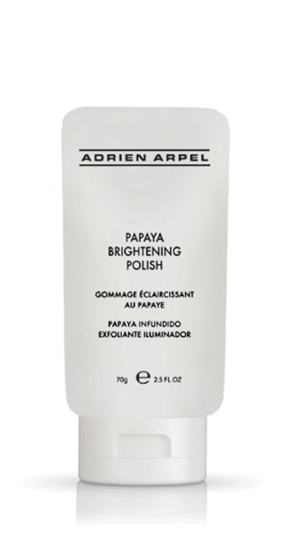
Papaya Brightening Polish

- Benefit Statement: An all-in-one brightening exfoliator that refreshes your skin with papaya enzymes and AHAs while sugar exfoliates to create a refined, more even-looking complexion. This creamy polish, gently releases debris, with Sugar and Lactic Acid (AHA) promoting healthy, natural skin turnover to instantly reveal glowing skin.
- HOW TO USE: Apply to moistened skin and gently massage in circular motions. Rinse thoroughly with tepid water. For enhance results, leave on skin for 5-7 minutes.

- How to Use: Apply to moistened skin and gently massage in circular motions. Rinse thoroughly with lukewarm water. For best results, leave on skin 5-7 minutes.

- Skin Types: All skin types.

- Key Ingredients: Carica Papaya (Papaya) Fruit Extract, Papain, Citrus Grandis (Grapefruit) Oil Sucrose (Sugar Ananas Sativus (Pineapple) Fruit Extract Citrus Aurantium Dulcis (Orange) Peel Oil Methyl Lactate (Lactic Acid) ,Milk ,Mentha Piperita (Peppermint) Leaf Oil and Lavandula Angustifolia (Lavender) Oil

Eye Care

Eye Perfection Crème
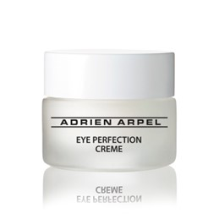
- Benefit Statement: Eye Perfection Crème is a triple action formula with key active ingredients clinically proven to address fine line and wrinkles. Eye Perfection Crème is readily absorbed into the delicate skin around the eye to hydrate, revitalize, smooth, de-puff and reduce the appearance of fine lines and wrinkles. Paraben, fragrance and gluten free.

- How to Use: Apply twice daily around the eye area and under the eyes. Gently pat cream into skin clockwise to avoid any unnecessary tugging of the skin.

- Skin Types: All skin types.

- Key Ingredients: Palmitoyl Oligopeptide & Pamitoyl Terapeptide-7 (Matrixyl®, , Alpha Lipoic Acid (ALA), Vitamin K, Co-Q10, Mushroom Extract).

Bio-Cellular Night Eye Gelee
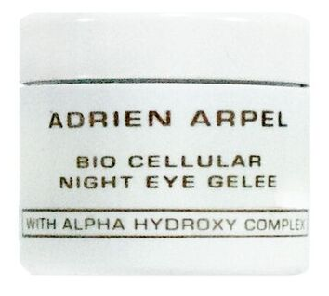
- Benefit Statement: “This delicate nutrient-enriched eye treatment penetrates the skin around the eyes, gently softening and smoothing visible lines. Also, reduces puffiness and dark circles. Gluten free.”

- How to Use: Apply a thin film to the eye area using a light, patting motion.

- Skin Types: All skin types.

- Key Ingredients: Sunflower Seed Extract, Malic Acid, Tartaric Acid, Lanolin, Beeswax, Elastin.

Serums

Alpha Advanced Ageless Elixir

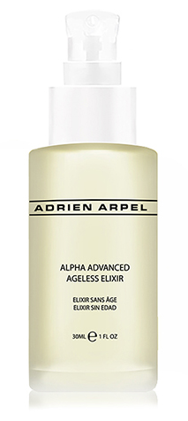
- Benefit Statement: This natural blend of multi-fruit acids (Bilberry, Sugar Cane, Sugar Maple, Orange, Lemon and Willow Bark Extracts) work to weaken the bonds that hold dead skin cells together, allowing a renewed surface that appears fresher, smoother and more youthful. Expect maximum cell renewal without the potential of irritation. Fragrance Free.
- HOW TO USE: Use after thoroughly cleansing of the skin. Let this light liquid absorb into the skin before applying your normal day or night creme. Avoid the eye area.
- SKIN TYPES: All skin types.
- KEY INGREDIENTS: AHA/BHA Hydroxy Acids, Sodium Hyaluronate, Panthenol, Vitamin E (Tocopheryl, and Vitamin C (Ascorbyl Palmitate, Vitamin A (Retinyl Palmitate), Allantoin, Phospholipids.

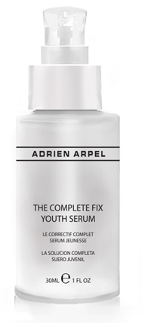
The Complete Fix

Benefit Statement: The Complete Fix Youth Serum is a laboratory proven fix for aging! This remarkable complex aids in the reduction of wrinkles while providing a lifting effect for all skin types. A clinical test with Palmitoyl Pentapeptide-4, a main ingredient, resulted in a 44% reduction of deep wrinkles, a 37% reduction of main wrinkle density and a 16% increase in lifting effect, while clinical tests with Bellis Perennis (Daisy) Flower Extract resulted in a reduction of melanin formation and anti-oxidative activity, providing significant evening of the skin tone. Fragrance, paraben and gluten Free.
- HOW TO USE: Apply two pumps into the palms of your hands and massage hands together to warm the product. Pat over entire face and neck. Use morning and night for optimal results
- SKIN TYPES: All skin types.
- Key Ingredients: Red Marine Algae, Acetyl Hexapeptide -3 (Argireline), Sodium Hyaluronate, Bearberry Extract (Uva Ursi Extract), Licorice Extract, Daisy Extract Antioxidants

Retinol PM Capsules – Facial Treatment Capsules
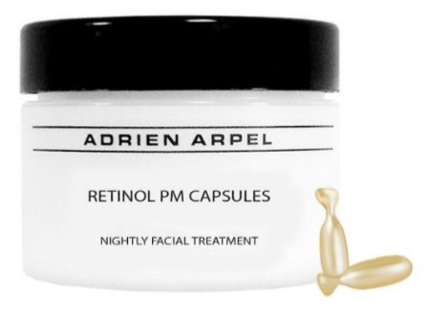
- Benefit Statement: “Retinol is considered to be the gold standard of anti-aging. Retinol PM Capsules feature a retinol molecular film fluid that stabilizes retinol and enhances its delivery and absorption. Because retinol is light sensitive, it is encapsulated it for maximum effectiveness in a non-animal derived, gelatin capsule. Retinol stimulates cell turnover to help prevent fine lines and wrinkles, and improve firmness, fullness and smoothness of the skin. It is also a natural exfoliant that helps to restore skin’s radiance, promote smoother skin and lessen visible imperfections such as scars and dark spots. Retinol repairs damaged tissue to both aged and photo-aged skin while controlling acne and pore-clogging impurities to keep skin moisturized. Paraben and fragrance free.”

- How to Use: Twist or cut the tail off the capsule and apply nightly onto face, lips and neck, avoiding the eye area. If irritation occurs, discontinue use.

- CAUTION: Those individuals with sensitive skin might experience tingling or a slight reddening of the skin. With continued use this should diminish. If irritation persists discontinue use and consult a physician. Do not apply to eyes or eye area. Keep out of reach of children. Not to be taken orally.

- Skin Types: All skin types.

- Key Ingredientes: Retinol (0.198% - 0.242%), Tocopherol

C Source – Facial Treatment Capsules

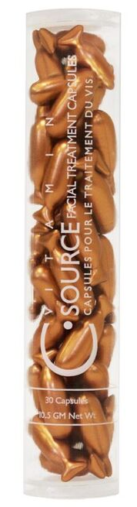
- Benefit Statement: “This silky formula of Vitamin C, encapsulated to ensure maximum stability and potency, supercharged with Vitamin E, a collagen boosting antioxidant, actively fights collagen breakdown and increases its production. This action delays the formation of lines and wrinkles while the Vitamin C softens the appearance of the existing ones. While many anti-aging products actually thin the skin and strip off layers to achieve a more youthful effect, C Source actually strengthens skin, reduces irritation, redness and sensitivity. Your skin appears softened, youthful and even-toned. Paraben, fragrance and gluten free.”

- How to Use: Cut or twist the tail of the capsule and apply one capsule daily to face and neck, immediately after cleansing and toning, avoiding the eyelids. Massage into skin and let soak in. Follow with normal treatment regimen. C Source can also be used to give skin an extra antioxidant boost, by adding the contents of these capsules to your specialty treatment or moisturizer.

- Skin Types: All skin types, including damaged skin

- Key Ingredients: Vitamin C (12%), Vitamin E (4%), Orange Blossom Oil.

Instant Super Serum
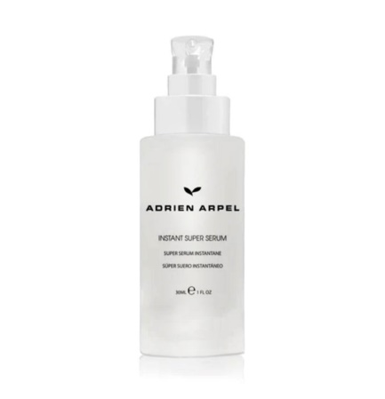
- Benefit Statement: “Contains hyaluronic acid and a tripeptide formula, to help smooth the appearance of fine lines and wrinkles, and instantly boost skin’s hydration, leaving it looking plumper, firmer, and more youthful”

- How to Use: Apply to cleansed, toned skin in a gentle upward and outward motion morning and night

- Skin Types: All skin types

- Key Ingredients: Squalene, Niacinamide, Palmitoyl Tripeptide-38, Sodium Hyaluronate, Cucumber Extract, Green Tea Extract, Vitamin E, Orange Peel Oil, Citric Acid

ANTI-AGING

Skin Correction Complex

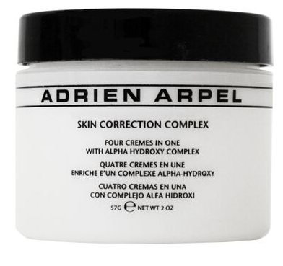
Benefit Statement: The one cream you need for younger looking skin. This highly effective formula is a day creme, night creme, wrinkle treatment and neck creme. . . four crèmes in one! Featuring 12 essential ingredients including a balanced blend of alpha hydroxy acids paired with skin loving lipids, Skin Correction Complex rejuvenates, smoothes, plumps and hydrates the skin, creating a younger and healthier looking complexion in one easy to use cream.

- How to Use: Apply day and night over face. Avoid eye area.

- Skin Types: All skin types.

- Key Ingredients: Jojoba Seed Oil, Apricot Kernel Oil, Olive Oil, Vitamin E, Malic Acid, Tartaric Acid, Lactic Acid, Glycolic Acid Glycerin, Avocado Oil, Sugar Maple Extract

Swiss Collagen Day Crème
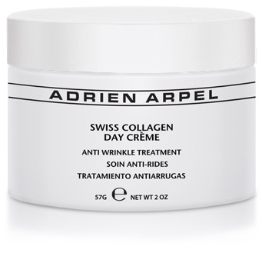
Benefit Statement: A non-greasy, light-weight, anti-aging treatment, Swiss Collagen Day Crème is formulated using a combination of the most up to date technology and Alpine botanical extracts that help reduce the appearance of lines as it moisturizes and hydrates, firms, and evens the skin tone, to promote healthy, younger looking skin.This firming day cream helps replace collagen loss. Suitable and effective for all skin types.

- How to Use: For best results apply daily to the face, neck and décolletage after cleansing and toning using upward, outward strokes. Avoid direct contact with the eyes. If irritation occurs, discontinue use. Apply moisturizer with SPF15 over Swiss Collagen Day Crème if needed.

- Skin Types: Normal, dry and aging skin types. Works well on mature skin that has an oily tendency.

- Key Ingredients: Glycerin, Dipalmitoyl Hydroxyproline, Soluble Collagen, Malt Extract, Edelweiss Flower Extract, Calendula Officinalis Flower Extract, Coneflower Extract, St. Johns Wort Extract, Menthol.

Bio-Cellular Night Crème

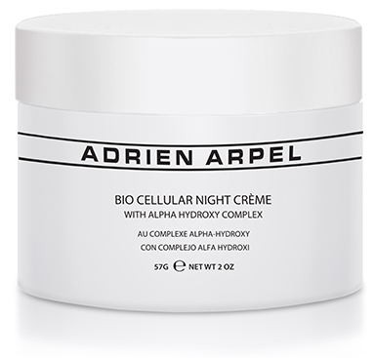
- Benefit Statement: “Formulated with gentle-acting Alpha Hydroxy Complex, this unique, grease-less cream is deeply hydrating while improving the elasticity and pliability of the skin, ultimately reducing the appearance of fine lines and wrinkles. With continuous use, the skin will appear brighter, clearer and smoother. Paraben free.”

- How to Use: Apply nightly all over face and neck. Avoid eye area. If irritation occurs, discontinue use.

- Skin Types: Normal to dry skin types

- Key Ingredients: Honey, Malic Acid, Glycerin, Aloe Barbadensis Leaf Extract, Vitamin E.

BODY treatments

Skin Correction Body Treatment Cream (8oz)

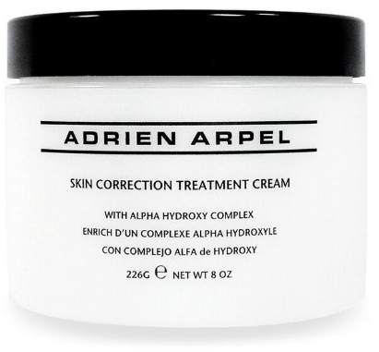
- Benefit Statement: “Rejuvenate the skin with this non-greasy, readily absorbed body crème. Skin Correction Body Treatment Crème incorporates an Alpha Hydroxy Complex along with Aloe, Jojoba Seed Oil, Vegetable Collagen and Sodium Hyaluronate to exfoliate, hydrate and nourish the skin. Paraben and gluten free.”

- How to Use: Smooth all over body daily, preferably after a shower or bath. May be used morning and night.

- Skin Types: All skin types.

- Key Ingredients: Glycolic Acid, Jojoba Seed Oil, Aloe Barbadensis Leaf Extract, Malic Acid, Tartaric Acid, Vegetable Collagen.

Face

Real Silk Bronzing Powder
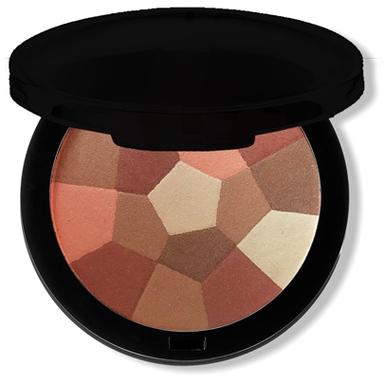
- Benefit Statement: “A lovely powder that finishes makeup with a delicate bronze veil. The kaleidoscope of glowing sun tones provides an instant natural glow without dangerous sun exposure. No one color dominates, they each blend for a perfect, natural looking appearance. You control the depth of color. May be used on most skin tones alone or with makeup. Also doubles as an eye shadow. Fragrance free.”

- How to Use: Apply with makeup brush all over the face. Wear alone or over makeup.

- Skin types: All skin types

