

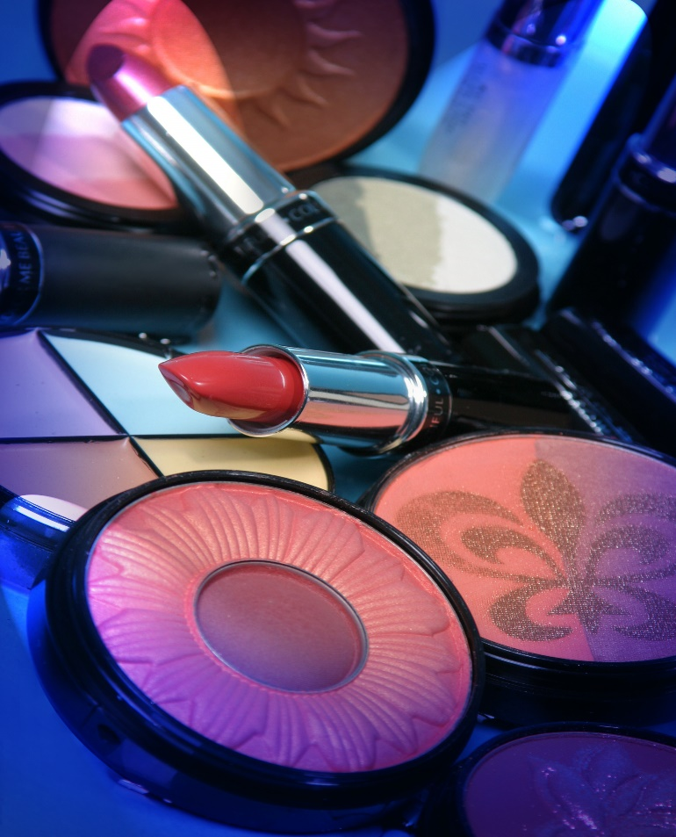

Product training manual
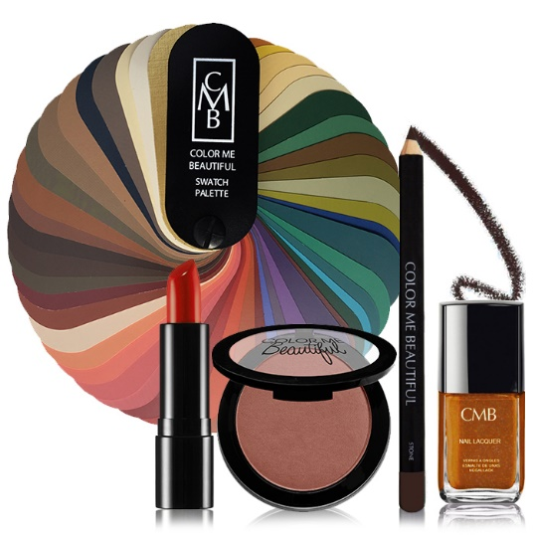

Color Me Beautiful is the authority on color – based on the bestselling books of the same name. Color Me Beautiful has sold 17 million copies worldwide and remains one of The New York Times’ all-time trade paperback best-sellers. Color Me Beautiful’s popularity is based on seasonal color theory and uses the seasons (Winter, Summer, Spring and Autumn) to describe what colors look best on individuals.
With the color analysis system, complete with draping provided by our trained Beauty Consultants, clients see for themselves their best colors. Through this system, the client is able to pull together her total look – clothing, accessories and makeup. Once she knows her season, and gets her color shopping guide, she’s able to buy her makeup, clothing and accessories in her best colors.
The Color Me Beautiful makeup brand is based on the best colors for a woman’s skin tone, eye color and hair color. As such, it is a highly personalized experience for each client. Once a client knows her season, there is no more guess work. She selects her lipsticks, eye shadows, blushes, glosses, eye pencils, lip pencils and all other products from her palette and presto, they all work together. Her eyes will be brighter, her teeth whiter and she’ll have a more youthful appearance. The system guarantees a coordinated look; she’ll always look great.
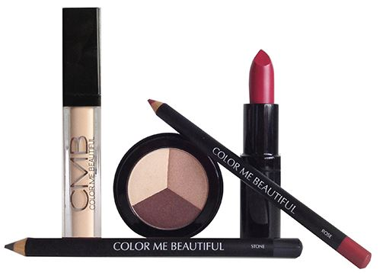
Color Me Beautiful uses mineral-based and other high quality ingredients. The products are long-lasting and go on silky and smooth. And, may have skin care benefits with anti-aging ingredients.
Color Me Beautiful is a multicultural brand sold internationally. Here in the United States, Color Me Beautiful is sold in, salons, boutiques, mall kiosks, through mail order/ecommerce.
Color Me Beautiful products are never tested on animals.

Skin Care

Cleansers
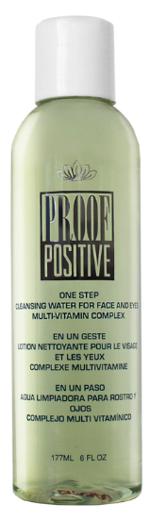

One Step
- Benefit Statement: “Cleansing and toning in one easy step. Great for touch ups and makeup removal. One Step’s vitamin packed formula provides skin tissue repair, UV protection, moisturization, and conditioning. Paraben free.”

- How to Use: Saturate cotton pad. Wipe eyelids, face and throat gently to cleanse.

- Skin Types: All skin types.

- Key Ingredients: Tocopheryl Acetate (Vitamin E), Retinyl Palmitate (Vitamin A), Vitamins C and B5.

Perfect Skin Tint Organic SPF 31 Moisturizer

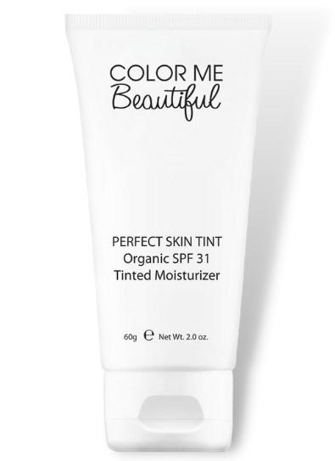
Perfect Skin Tint

- Benefit Statement: “A powerful, tinted beautifier that offers SPF protection (Full Spectrum SPF31) to defend against indoor and outdoor daily aggressors. Easy to blend, it offers a hint of color while leaving the skin soft, hydrated, and prepped for makeup application”
- How to Use: Apply liberally 15 minutes before sun exposure. Use a water-resistant sunscreen if swimming or sweating
Reapply:
- after swimming or sweating
- immediately after towel drying
- at least every 2 hours

anti-aging

C-Plex
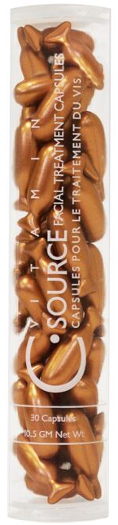
Benefit Statement: “This silky formula of Vitamin C is encapsulated to ensure maximum stability and potency and it’s supercharged with an effectiveness boosting dose of Vitamin E. This power-packed antioxidant duo uses amazing properties to actively fight collagen breakdown and increase its production, this action literally delays the formation of lines and wrinkles while the vitamin C softens the appearance of existing ones. While many anti-aging products actually thin the skin and strip off layers to achieve a more youthful effect, C Source actually strengthens skin, reduces irritation, redness and sensitivity. Your skin appears more softened, unlined, even-toned with a radiant glow. Thirty capsules per bottle, a one month supply for face and neck areas. The formula is encapsulated to ensure maximum effectiveness and stability, using a brand new V-Gel™ technology. The new soft gel capsules are derived from seaweed. Paraben, fragrance and gluten free.”

- How to Use: Cut or twist the tail of the capsule and apply one capsule daily to face and neck, immediately after cleansing and toning, avoiding the eyelids. Massage onto skin and let soak in. Follow with normal treatment regimen.

- Skin Types: All skin types (including sun damaged skins).

- Key Ingredients: Vitamins C & E, Orange Blossom Oil.

MAKE-UP MAGIC

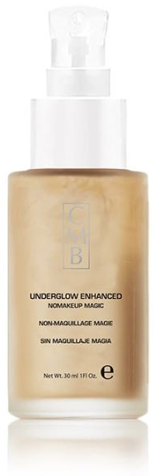
UnderGlow Enhanced Light Diffusing Gel

- Benefit Statement: “Helps to soften the appearance of fine lines and hide imperfections. This “enhanced” formula incorporates SYN®HYCAN, a tri-peptide clinically proven to help boost skin’s hyaluronan production and allow needle-free HA based face contouring for a visible remodeling effect and firmer skin. Paraben, fragrance free.”

- How to Use: Apply evenly to face and neck on clean skin. Can be worn under makeup or alone. Can also be applied to highlight areas such as cheekbones and brow bones as a final step.

- Skin Types: All skin types.

- Key Ingredients: Syn®-Hycan (2.5%), Aloe Vera Leaf Extract, Glycerin.

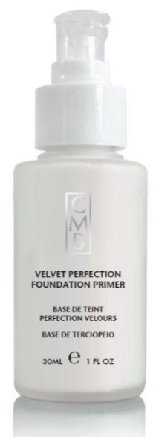
Velvet Perfection Foundation Primer

- Benefit Statement: “This oil-free formula combines antioxidants and Vitamins A and E to protect and sooth the skin while reducing the appearance of fine lines and wrinkles resulting in radiant skin. With silicone-derived ingredients that prevent moisture loss, Vitamins A and E that fight free radicals and light reflecting ingredients that provide a luminous quality, the skin will appear younger and more radiant. Paraben and fragrance free.”

- How to Use: Use after moisturizer and before foundation for complexion perfection. This skin-smoothing blend of antioxidants, which can be word alone or under foundation, works overtime to fill in fine lines and even out skin texture.

- Skin Types: All skin types.

- Key Ingredients: Silica, Tocopheryl Acetate (Vitamin E), Retinyl Palmitate (Vitamin A).

Corrective Color Wheel

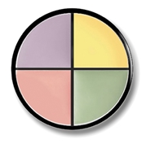
- Benefit Statement: Four targeted concealers in one easy to use container. Pale Yellow neutralizes purple shadows, calms mild redness and covers dark under eye area. Mint corrects redness from Rosacea, sunburn and blemishes. Lavender blends away sallowness and brightens dull skin. Mauve neutralizes brown to conceal dark areas and brighten the skin. The shades can be mixed for perfect correction. The creamy formula gives the skin a soft, smooth appearance. Paraben and Fragrance Free.
- How to Use: Dot a neutralizing concealer on carefully and blend with your fingertips slightly past the edges of the problem area. (For best results, do not use a sponge to apply, as concealers will take on the pattern of the sponge. Use fingertips.) Let set.
- Skin Types: All skin types.

- Key Ingredients: Cocoa Nucifera (Coconut) Oil, Helianthus Annuus (Sunflower) Seed Oil
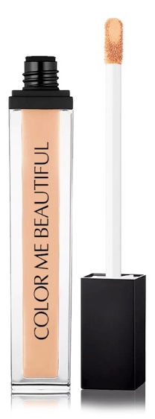
Miraculous Cream Concealer & Eyeshadow Base
- Benefit Statement: “A creamy, full coverage, long wearing concealer and eyeshadow base that not only conceals it also sets eyeshadow for all day wear. Apply once then set with your favorite powder and you're ready to go for 12 hours.”

- How to use: Use edge or tip of applicator to sculpt with a finer line for precision. Use flat side for fuller delivery.

- Skin Types: All skin types.

- Key Ingredients: Liquid Paraffin, Petrolatum, Ozokerite Wax, Beeswax, Cetyl Esters, Lanolin, Zinc Stearate, Phenoxyethanol

Color Fix Lipstick Sealant
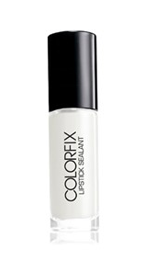
Benefit Statement: ColorFix has a clear, serum-like texture that transforms any cream lipstick into a velvety matte-ish finish that's never chalky and stays all day. Now you can wear your favorite lipstick shades 2 ways, minus the mess of DIY mattifying methods. Just apply over any lipstick for a matte makeover instantly.This updated formula is never drying or irritating. By removing the alcohol, you get gorgeous-looking lipstick that stays in place all day!

- How to use: Apply holding lips apart and still for 30 seconds. Do not blot.

- Skin Types: All skin types.

- Key Ingredient: Silica, Sodium Hyaluronate.

color cosmetics – FACE

Morning Light Diffusing Cream Foundation

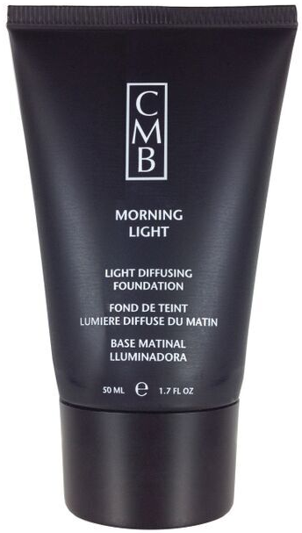
- Benefit Statement: “This creamy, silky foundation diffuses light away from lines and shadows on the face, especially around the eyes. Morning Light evens skin tone and makes the skin appear smooth and flawless. Gluten free, Available in four shades: Amber, Ivory, Oyster & Porcelain.”

- How to Use: For heavy coverage, apply with a dry cosmetic sponge. Dab on to the nose, cheek, forehead and chin areas, then blend with a stippling action. Pay special attention to jawbone and facial features to ensure a smooth and natural finish.
- For normal to light coverage, apply with a dampened sponge, otherwise as above. Larger pore areas may require greater pressure on application. Feather blend edges to ensure an even result.

- Skin Types: Normal to dry skin.

- Key Ingredients: Propylene Glycol, Avocado Oil, Wheat Germ Oil, Aloe Vera.

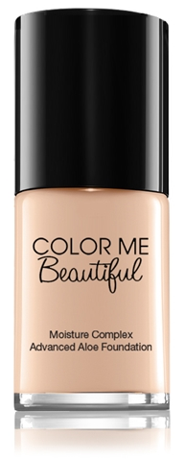
Moisture Complex Advanced Aloe Foundation

- Benefit Statement: “This foundation is heavily enriched with Aloe Vera to give your skin a youthful, hydrated appearance. Blends easy and goes on smooth. Cap comes with built in spatula for easy application. Paraben and gluten free.”

- How to Use: For best results, apply over moisturizer or primer in light layers until desired coverage is achieved. Works beautifully with Multi-Tasking sponge.
- Skin Types: Normal to dry skin.

- Key Ingredients: Aloe Barbadensis Leaf Juice, Propylene Glycol, Caprylic/Capric Triglyceride, Myristal Myristate, Glyceryl Stearate, Dimethicone, and Citric Acid.

Perfection Microfine Powder Foundation
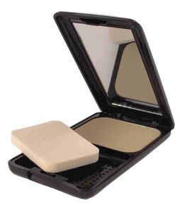
- Benefit Statement: “Highly pigmented, finely milled powder foundation features sheer to full buildable coverage. Dual purpose may be used wet or dry depending on desired finish. Contour, highlighting, set makeup and touchups, Perfection Microfine Powder does it all. Paraben and fragrance free. Available in two shades: Whisper Beige & Sepia Beige.”

- How to Use: For a sheer matte effect, apply over moisturizer or primer with sponge, or dust on with powder brush. For full coverage, blend on with damp sponge. For use as a finishing powder, use over foundation. Latex free sponge.

- Skin Types: All skin types.

- Key Ingredients: Squalane, Kaolin.

Flawless Mineral Loose Foundation
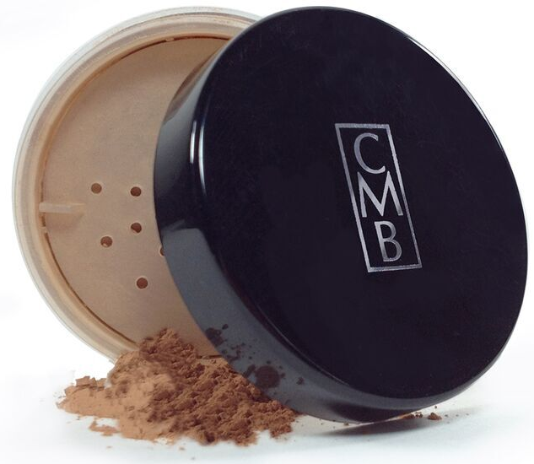
- Benefit Statement: “Experience the hydration and brightening of our newest age-defying mineral foundation. Aloe, rice lipids and jojoba hydrate, while a White Sapphire Complex creates a soft-focus effect leaving the skin looking radiant. Brush away the signs of aging with this mineral foundation that visibly erases pores, lines and imperfections, for a naturally flawless, ageless look. Long lasting coverage erases imperfections. Lightweight formula ensures daylong comfort. Free of talc, oil, parabens, fragrance and gluten. Available in three shades: Light, Beige & Tan.”

- How to Use: Pour Flawless Mineral Loose Foundation into the lid of its jar. Dip brush into the powder and swirl to pick up then tap to knock off the excess. Lightly brush the foundation all over the face in a swirling motion. Recommend Kabuki Brush.

- Skin Types: All skin types.

- Key Ingredients: Aloe Barbendis Leaf Extract, Honeysuckle Extract, Oryza Sativa (Rice) Lipids, Synthetic Sapphire.

Color Pro Blush

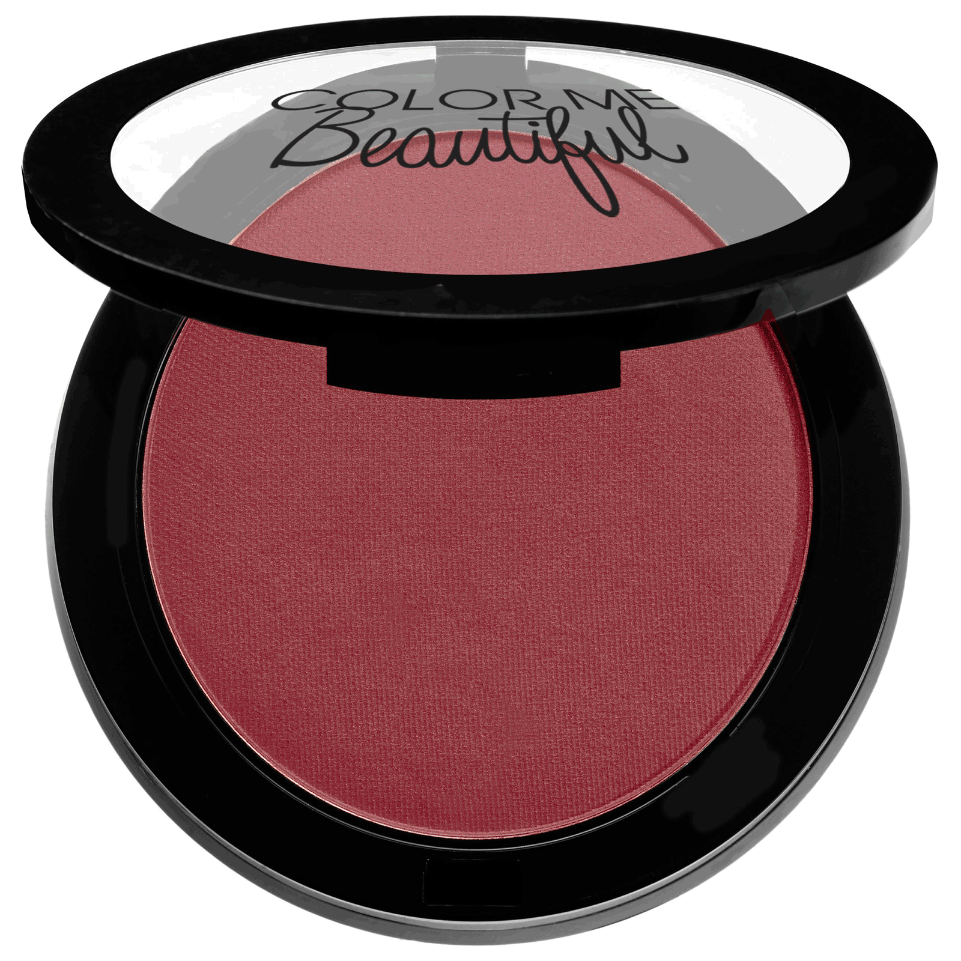
- Benefit Statement: Color Pro Blush is pigment rich and gives you a healthy and radiant glow to flatter any skin tone. Pigment pure, blendable and easy to layer. This professional quality blush is formulated to makeup artist’s specifications.
- HOW TO USE: Apply after foundation and powder. Use Angled Blush Brush and apply to the apples of the cheek. Sweep the excess across the hairline, bridge of the nose and chin. Start with a soft application of color, building up layers depending on the intensity desired.
- SKIN TYPES: All skin types

COLOR COSMETICS - eyes

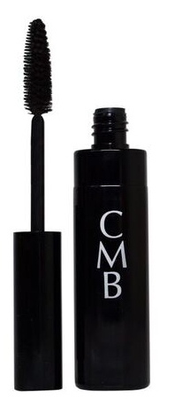
Sensitive Eyes Mascara

- Benefit Statement: “Lengthen, separate and darken lashes without clumping or smudging. Sensitive Eyes Mascara’s water-based formula is hypo-allergenic, fragrance and gluten free for the most sensitive eyes. Available in three shades: Black, Brown & Navy.”

- How to use: Use the side of brush to apply to lower lashes first, and then apply to upper lashes. Use the point of the brush for inner and outer lashes.

- Skin Types: All skin types.

- Key Ingredient: Panthenol (Vitamin B5), Beeswax, PVP

Waterproof Automatic Brow Pencil

- Benefit Statement “Looks like a brow pencil, but this is a precision instrument for filling in and shaping up brows, with an easy to use, self-sharpening point. The formula is creamy and smooth with no drag which allows for easy application. The brush end is perfect for softening the application so your brows look beautifully natural. Once set (which takes about three minutes) your brows will look beautiful all day. Fragrance free. Available in three shades: Taupe, Light Brown & Dark Brown.”

- How to use: Apply with light strokes, than blend by brushing through with eyebrow brush. Repeat for build-up if desired.

- Skin Types: All skin types.

- Key Ingredients: Ethylhexyl Palmitate, Beeswax, Squalene, Lanolin Oil.

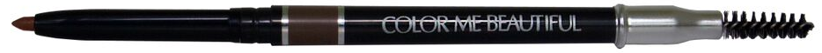

Beautiful Brow Duo

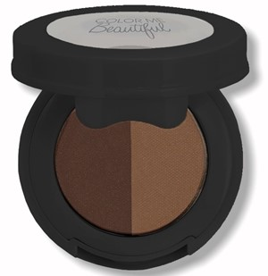
- Benefit Statement: “Brow Powder Duos gives you the ability to customize your exact brow color. Brow Powder Duos are easy to use with a natural application that's smudge-proof. This two-shade brow powder compact creates the perfect customizable brow using light and dark hues.
- How to Use: Use short, light strokes, to fill in sparse brows. Apply the powder onto the brow using a brush or spoolie.
- Skin Types: All Skin Types
- Key Ingredients: Ingredients are subject to change, for most up to date ingredients check the label on your product

Waterproof Automatic Eye Pencil

- Benefit Statement: “Delivers a sexy line of water-proof color, with an easy-glide, creamy formula. Its smudger end makes this a must have for eye-mazing looks. Fragrance and gluten free. Available in five shades: Black Magic, Dark Chocolate, Perfect Grey, Rich Navy & Khaki.”

- How to use: Perfect to wear alone or with eye shadow to emphasize the beauty of your eyes.

- Skin Types: All skin types.

- Key Ingredients: Lanolin Oil, Beeswax, Squalene.
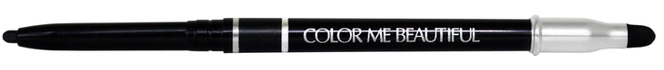

Color Pro Single Eyeshadow
- Benefits: “Highly pigmented color that lasts all day in an easy to use compact. Luxurious and radiant shades. Smooth application with natural light diffusing minerals. For best results, use Color Me Beautiful Eye Shadow Base first. Fragrance, paraben and gluten free.”

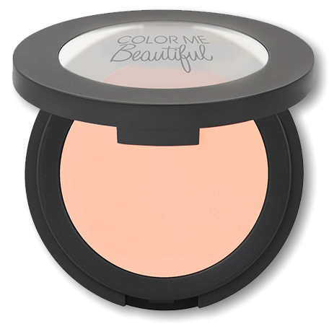
- How To Use: To encourage long lasting color for your lids, use over our eye shadow base. Apply the main accent color over the eyelid. Use the darker contour shade in the crease of the eye. A light shade should be used underneath the brow as a highlighter. Then soften and blend away any harsh lines with a make-up sponge.

- Skin Types: All skin types

- Featured Key Ingredients: Mica, Lavender Oil, and Silica

COLOR COSMETICS - LIPS

Chroma Soft Lip Pencil

- Benefit Statement: “Keep your lipstick where it belongs. This luxurious non-transfer formula prevents feathering and helps maintain lip color throughout the day. Paraben, fragrance and gluten free. Available in seven shades.”

- How to use: Apply after lip base on the entire natural lip contour. To minimize lips, line on the inside edge of the mouth. To maximize smaller lips, line the extremes of the outer edge. For dramatic effects use a darker liner with a softer shade of lipstick, and for a deeper long lasting color, use the liner to cover the entire lip area using a lip brush to blend and then follow with lipstick.

- Skin Types: All skin types.

- Key Ingredients: Mica, Caprylyl Glycol.
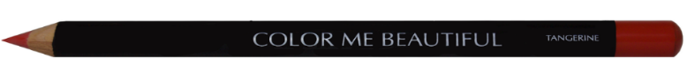

Design Line Lip Pencil
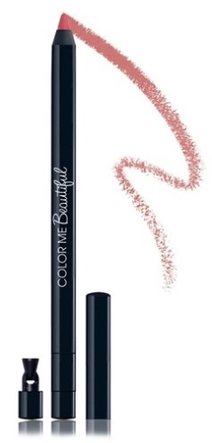
- Benefit Statement: A retractable gel lip liner that lines and primes lips for a long-lasting, full appearance.
- How to Use: Apply to the outer lines of lips and fill in color all over lips.
- Skin Types: All Skin Types

- Key Ingredients: Shea Butter, Mica, Silica

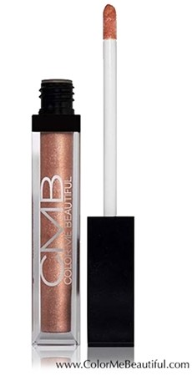
Extreme Sheen Lip Gloss
- Benefit Statement: Wear over lipstick or alone for a dazzling pop of color and brilliant shine.
- How to Use: Apply the lip gloss with the wand applicator to ensure smooth application. Can be worn over lipstick or alone.
- Skin Types: All Skin Types
- Key Ingredients: Cera Alba (Beeswax)

Color Renew Lipstick

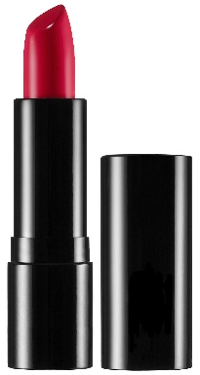
- Benefit Statement: A deluxe lipstick that delivers high-impact color in one stroke with a weightless, creamy texture that applies like satin. Premium ingredients condition, hydrate and smooth the lips.
- How to use: Apply lipstick after lip base (if applicable) and lip pencil.

- Skin Types: All skin types.

- Key Ingredients: Tocopherol (Vitamin E), Silica, Citric Acid, Ascorbyl Palmitate, Sodium Hyaluronate,.

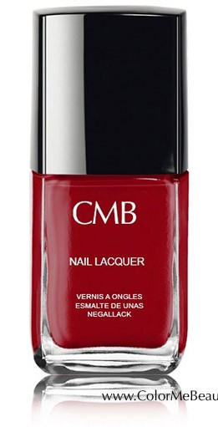
Nail Lacquer

- Benefit Statement: “Look polished from head to toe with a

- stunning new array of ten Nail Lacquers from Color Me Beautiful. CMB brings its decades of color expertise and a fresh sexy attitude to this elegant array of sophisticated shades. Formaldehyde, Toluene and Dibutyl Phthalate (DBP) free. Also camphor-free. Glossy, fast drying, long wear, smooth application, excellent inter-coat adhesion to base coat and top coat, reinforces and protects nails. Paraben and fragrance free.”

- How to use: For a flawless nail lacquer application first apply basecoat on a clean, dry nail. Allow to dry to the touch prior to applying nail lacquer. Apply two coats of nail lacquer. Allow each coat to dry prior to applying additional coat. Finish with topcoat if desired.

